 | Document Number: |  |  |  | GYS/RGD/TSP/0287
 | Document Title: |  |  |  | Highways Agency HLD WP199 MMLite Circee and IAMS
 | Document Type: |  |  |  | High Level Design
5 |  | 04.04.12 |  | IAMS Phase HLD - revised after 29.03.12 Review Comments from Peter D
4 |  | 23.03.12 |  | IAMS Phase HLD and Circee Phase HLD - revised after 06.03.12 Review session with HA and FLUOR |  | MA
3 |  | 02.03.12 |  | First Submission of IAMS Phase HLD |  | MA
2 |  | 27.02.12 |  | Second Submission of Circee HLD to Fluor and HA |  | MA
1 |  | 08.02.12 |  | First Submission of CIRCEE HLD to Fluor and HA |  | MA
REV |  | DATE | PAGE QTY | DESCRIPTION |  | AUTH | SPONS | GeneSYS | HA Consent
REVISION |  |  |  |  |  | APPROVALS |  | ACCEPTED

FUTURE PLANNED REVISIONS

Planned Amendment | Reason for Amendment | Planned date for next revision

Brief Description of Document:

This document presents the high level design for the OSS solution in support of the MMLite IAMS deployment.

Date Initiated: |  | Due date to CDCG for Lead Review: | [Ask Fluor sponsor for due date]

Record of Internal Revision

Revision | Date | Name | Review Comments | Project Control Check
0.1 | 31Jan 2012 | Mike Aslan | First Draft
0.2 | 08 Feb 2012 | Mike Aslan | Internally Reviewed
0.3 | 08 Feb 2012 | Mike Aslan | Internally Reviewed
0.4 | 13 Feb 2012 | Mike Aslan | Circe HLD that went out to Fluor
0.5 | 21 Feb 2012 | Mike Aslan | First draft of IAMS HLD
0.6 | 24 Feb 2012 | Mike Aslan | Internally Reviewed
CONTENTS
CONTENTS 4
LIST OF FIGURES 7
LIST OF TABLES 9
ABBREVIATIONS 10
OBJECTIVES 11
1 Introduction 14
1.1 Purpose & Scope 14
1.2 Project Roles and Responsibilities 16
1.3 Background and Business Drivers 16
1.4 Links and references 17
1.5 Problem or Vision Statement 19
2 Service Impacts 21
2.1 Service Type ST8RH 22
2.2 Service type ST8RDH 23
2.3 Service TYPE ST8RC2 25
2.4 Service Type ST8RCO1 26
2.5 Service Type STRCO2 27
2.6 Service Type ST8RCO2D 28
2.7 Service type ST10C2 29
2.8 Service Type ST10C2D 31
2.9 Service Type ST10C01 32
2.10 Service Type ST10C02 33
2.11 Service Type ST10C02D 34
3 System Architecture 36
3.1 System Functional Architecture 36
3.1.1 Functional Architecture Diagram 36
3.1.2 Description of System 37
3.2 Subsystem Functional Architectures 38
3.2.1 Netcool Functional Changes 38
3.2.2 Circee Functional Changes 48
3.3 Data model 61
3.3.1 High Level Data Model 61
3.3.2 Data Ownership Principle 64
3.4 Use Cases 65
3.4.1 Inventory Management 65
3.4.2 Fault Management 82
3.5 Business Processes 88
3.6 Data Flow 88
3.7 Interfaces 89
3.7.1 External Interface Changes 89
3.7.2 Internal Interface Changes 89
4 Non-Functional Architecture 91
4.1 Capacity and Dimensioning 91
4.2 Migration 92
4.3 Availability 92
4.4 Back up and Restore 93
4.5 Data Storage 93
4.6 Security 93
4.7 Reliability 93
5 Impacted Functional Specification Documents 95
6 Requirements and Solution Traceability 97
6.1 Functional Requirements and Requirements Mapping 98
7 Alarm Lists 110
7.1 7210SAS-M IAMS Alarm List 110
7.2 7210SAS-D IAMS Alarm List 111
7.3 Telindus Solo MPEG-2 Encoder Alarm List 112

LIST OF FIGURES
Figure 1 - Managed Motorways Lite Schematic Diagram 19
Figure 2 – Service Type ST8RH offered by a 7210SAS-D 22
Figure 3 - Service Type ST8RDH Offered via 7210SAS-D 23
Figure 4 – Service Type ST8RDH offered by a 7210SAS-M 24
Figure 5 – Service Type ST8RC2 offered by a 2-port copper Solo 25
Figure 6 – Service Type ST8RCO1 offered by a 1-port fibre Telindus Solo MPEG-2 Encoder 26
Figure 7 – Service Type ST8RCO2 offered by a 2-port fibre Solo 27
Figure 8 – Service Type ST8RC02D offered by a 2-port fibre Solo 28
Figure 9 – Service Type ST10C2 offered by a single 2-port copper Solo 29
Figure 10 – Service Type ST10C2 offered by a 2-port copper Solo on in a chain 30
Figure 11 - Service Type ST10C2D offered by a 2-port copper Solo 31
Figure 12 – Service Type ST10C01 offered by a 1-port fibre Solo 32
Figure 13 - Service Type ST10C02 offered by a 2-port fibre Solo 33
Figure 14 - Service Type ST10C02D offered by a 2-port fibre Solo 34
Figure 15 - Functional Architecture Diagram - Managed Motorways Lite 36
Figure 16 - Netcool Functional Changes 38
Figure 17 - Service Category 8 Outage Triggers 43
Figure 18 - loss of link to control port of camera 46
Figure 19 - Service Category 10 Outage Triggers 47
Figure 20 - Circee Component Design Changes 54
Figure 21 - naming examples – single 10 GE backup link across all SASMs is assumed 58
Figure 22 - SASD naming examples 59
Figure 23 - SOLO naming examples 60
Figure 24 - High Level Data Model 61
Figure 25 - Data Repository Changes 62
Figure 26 - Data Ownership 64
Figure 27 - Inventory Management Use Case diagram 66
Figure 28 - Create Service Activity diagram 67
Figure 29: Populate Service Activity diagram (Pt1 of 2) 69
Figure 30 - Populate Service Activity diagram (Pt 2 of 2) 70
Figure 31 - Provision Service Activity diagram 72
Figure 32 - Activate Service Activity diagram 74
Figure 33 - Decommission Service Activity diagram 75
Figure 34 - Rectify Data Activity diagram 77
Figure 35 - Cancel Service Activity diagram 80
Figure 36 - Fault Management Use Case diagram 83
Figure 37: Record Alarm-Clearance Alarm Activity diagram (Pt 1 of 2) 84
Figure 38 - Record Alarm-Clearance Alarm Activity diagram (Pt 2 of 2) 85
Figure 39 - Investigate Alarm Activity diagram 87

LIST OF TABLES
Table 1 - Roles and Responsibilities 16
Table 2 - Background and Business Drivers 17
Table 3 - Circee Requirements Coverage 50
Table 4 - Catalogs and Templates 52
Table 5 - Server Sizing Guidelines 92
Table 6 - List of Impacted Functional Specification Documents 95

ABBREVIATIONS
APTR | All Purpose Trunk Roads
CEC | Combined Equipment Cabinet
CTU | Camera Termination Unit
DMS | Document Management System
HA | Highways Agency
HLD | High Level Design Document
IAMS | Interim Alarm Management Solution
NRTS | National Road Transport Systems
OSS | Operations Support System
PTZ | Pan, Tilt and Zoom
QDT | Quinton Data Team
RMD | Roadside Multiple Diversity
SCR | Service Credits Regime
SDP | Service Delivery Point
SoR | Schedule of Requirements
SPC | Service provision capability
SLT | Service Level Targets
SPC | Service Provision Capability
ST | Service Type
STI | Service Type Instance
WP | Work Package
OBJECTIVES
The purpose of this document is to provide the High Level Design for the Circee and IAMS (Interim Alarm Management Solution) phases of Work Package 199 for the Highways Agency project. The document details the delta OSS design changes needed in support of Managed Motorways Lite. It represents the design for phase 2 of the solution. Phase 3 will provide the full solution, including the remaining Netcool and Circee updates for basic alarm handling, and the solution for the Netcool parent/child correlation.
This document captures the ‘delta’ to the base service charge solution [1] and does not document the system as a whole. It will ultimately be used to update the registered Functional Specification documents and other assurance documents, as necessary.
This document is an iterative document:
- the first Revision contained the Circee phase HLD;
- this current Revision consists of the IAMS phase HLD (contains the Circee phase HLD);
- the final Revision will contain the full HLD (which will build on the IAMS phase HLD).
The objective of the Circee HLD was to describe the changes that needed to be made to the inventory system (Circee) accompanied by the Asset and Service Templates
The objective of the IAMS phase is the automatic creation of trouble tickets as per the defined outage triggers (see section 3.2.1.9). Only the 25 alarms from the 7210 switches identified as potentially service affecting will be processed in this phase. The current system already receives alarms from 1-port copper Solo Telindus MPEG-2 encoders. The variants used by MMLite will send the same alarms, but they may be treated differently (for example, with regards to outage triggers).
This document describes the Managed Motorways Lite solution, in terms of changes to:
- Supported Services
- System Architecture (as a whole)
- Sub-system Architectures (functional) for Netcool and Circee
- Data Model for Netcool and Circee
- Use Cases and Business Processes
- Non-functionals, including Capacity Modelling and Migration
- Functional Requirements
Unchanged system elements are described to give background and context.
The detailed design of each Subsystem described in the HLD will be provided by a Low Level Design Part 1 (LLD Part 1), which will be subsequently included as a distinct section of this document, and a Low Level Design Part 2 (LLD Part 2), which will exist as a separate document. The LLD Part 1 will provide the logical detailed design, the LLD Part 2, the physical detailed design
SECTION 1: Introduction

Introduction

Purpose & Scope
Work Package 199 is to deliver an OSS Solution to provide management of Managed Motorways Lite solution into the HA/NRTS network. The OSS solution will provide functionality in line with the contractual requirements stipulated in the statement of requirements.
The scope of the project in its entirety is limited to the following OSS subsystems.
- Fault Management – Management of fault alarms coming from the Managed Motorways Lite active devices (7210SAS-M, 7210SAS-D and Telindus Solo MPEG-2 Encoders).
- Inventory – Modelling and management of Managed Motorways infrastructure and services including Active, Passive and Civil aspects.
- Maintenance – Modelling of Managed Motorways Lite devices in the maintenance solution
- Trouble Ticketing – Support for the new devices and service types to be introduced as a result of the Managed Motorways Lite deployment (see section 3.2.1.9 – outage Triggers).
- Performance Management – support for the new devices and services to be introduced as a result of the Managed Motorways Lite deployment.
The delivery at phase 2 of the project will deliver the bulk of the Inventory (Circee) capability and a basic alarm handling solution (a.k.a. Interim Alarm Management Solution (IAMS)) within Netcool. The scope of each of the Circee and Netcool delivery aspects is enumerated below:
Netcool Scope:
- Alarm field mapping & formatting (including Severity & Summary)
- Problem/resolution event identification and processing
- De-duplication
- Fixed lookup tables (i.e. lookups with permanent/static values)
- Calculation of affected STIs + outages
- Simple enrichment (e.g. external Asset data queries in Circee)
- Automatic trouble ticketing (as per Outage Triggers)
- This basic alarm handling solution will be applied to the subset of alarms that are service affecting and to those that are potentially resilience affecting (as identified in the IAMS Alarms List)
- Customer view showing potentially resilience affecting alarms.
Note that the handling of Cabinet alarms is not in scope for this work package.
This solution assumes that the 5620 SAM element manager release 9 will be used for the IAMS phase. This has yet to be verified. The upgrade of the 5620 element manager to version 9, and the upgrade of the 5620 probe to version 9 are pre-requisites of this Work package.
This solution is based on the Infrastructure Scenarios defined in document [6].
Circee Scope:
- Delivery of equipment templates and catalogue items
- Delivery of service templates
Note: the capability of setting Cable Types with SPC-E service provisioning capability (via the SDP_LOCALITY field) is excluded from the IAMS phase. Further discussions between Alcatel, Fluor and GeneSYS will be held to confirm whether this is out of scope for this Work Package.
Similarly, any functionality related to new GIS overlays for any new cable types to be created for MMLite will be excluded from the IAMS phase.
Finally, no new cabinets will be created during the IAMS phase.

Project Roles and Responsibilities
Table 1 describes the roles and responsibilities of the people (GeneSYS, HA and Interfacing Organisations) involved in this process.
Name | Role
Ritu Bugli | ALU Project Manager
Gavin Barlow | ALU Lead Solution Architect
Sean Hannah | ALU Lead Technical Project Manager
Michael Aslan | ALU Solution Architect
Hunter Barr | ALU Lead Business Analyst
Stewart Menzies | Fluor OSS Manager
Stuart Turner | Fluor GeneSYS NOC Manager
David Bolton | Fluor GeneSYS Deputy NOC Manager
Table 1 - Roles and Responsibilities

Background and Business Drivers
Business Driver | Realisation | Associated Business Requirements | Phase
Service-level views of events from the Network provide an additional level of Fault Management; the events alone (Element Manager information) cannot provide this. This enables the NOC to satisfy the Fault Management SLTs. | The raw events generated by the element managers are de-duplicated, cleared, and enriched, the views of outages as provided by the set of configured outage triggers. | BR506, BR507, BR510, BR511, BR512, BR514, BR518, BR580 | IAMS, Full
Trouble Tickets will automatically be created as per the outage triggers and linked to the associated Service Type Instances, reducing the amount of operational time spent creating and linking the required information, hence reducing the amount of time to resolve faults, and enabling the NOC to satisfy the Fault Management SLTs. | Omnibus is connected to APM via a gateway, which is configured to allow the appropriate types of alarms to pass through and create trouble tickets in a timely fashion. | BR513 | IAMS, Full
End-to-End Service and Device specific performance related information will be automatically collected and raised providing pre-emptive alerts to be created in the Fault Management system. | The monitoring provided by Proviso allows detection of various thresholds being reached, so that preventative measures can be taken before a fault occurs. | This functionality has been deferred to be delivered in a future phase. | Full
This work package will deliver full traceability from Requirements (including coverage of Schedule of Requirements and SLT Requirements) through Design, Development & Test with regular Internal gates including all Internal stakeholders to ensure quality is maintained throughout the delivery lifecycle. During each of these stages the impact of the work is continuously assessed to ensure minimal impact to the existing OSS Solution. | Each relevant component of the OSS solution will be amended so that the new equipment can be managed by Fluor with minimal impact to their operational processes. | BR495, BR498, BR497, BR503 | IAMS, Full
Table 2 - Background and Business Drivers

Links and references
Reference | Document Name | DMS Document ID
 | GYSRGDSSP0001_R10 PS-DS036 NRTS System Architecture | GYS/RGD/SSP/0001
 | Managed Motorway Lite Variation Report - Revision 3 | GYS/HWA/LTR/0630
 | Outline Specification for WP199 - REV01.3.doc | n/a
 | GYSRGDSSP0104_R03.0 PS-DS036-200 OSS Global Data Model.doc | GYS/RGD/SSP/0104
 | GYSRGDPRP0008_R12 Fault Management (PS DS010).doc | GYS/RGD/PRP/0008
 | Infrastructure Scenarios defined for Work Package 199 – Version 1.4 (MM Lite-Infrastructure-Scenarios-V1.3.doc) | n/a
 | Alarm List defined for Work package 199 – version 2012-1.6 (MMLiteAlarmList-V2012-1.6.xls) | n/a
 | Circee Templates defined for Work Package 199 – version 12 (MM-Lite-Templates-for-Circee-and-D7i-v12) | n/a
 | Create Service Use Case v0.2 | n/a
 | Populate Service Use Case v0.2 | n/a
 | Provision Service Use Case v0.2 | n/a
 | Activate Service Use Case v0.2 | n/a
 | Deactivate Service Use Case v0.2 | n/a
 | Rectify Data Use Case v0.2 | n/a
 | Cancel Service Use Case v0.2 | n/a
 | Circee Service Templates | n/a
 | Record Alarm-Clearance Alarm Use Case v0.1 | n/a
 | Investigate Alarm Use Case v0.1 | n/a
 | GYSRGDSSP0009_R21 PS-DS036-05 Functional Specification Circee.doc | GYS/RGD/SSP/0009
 | MMLite Design Rules | GYS/RGD/TSP/0289

Problem or Vision Statement
The OSS capability is required to manage the introduction of the Managed Motorways Lite solution.
The key drivers for Managed Motorways Lite are reduced infrastructure costs, reduced Opex costs and a solution suitable for deployment in both fibre rich and fibre poor sections of the motorway.
The solution pushes IP closer to the edge, performing CCTV encoding at the roadside rather than in remote Transmission Station locations. It uses smaller transmission cabinets to support services with network devices (7210SAS-M and 7210SAS-D) and camera encoding devices (Telindus Solo MPEG-2 Encoder) which are both environmentally hardened. For cost reasons, a hierarchical design has been elaborated, using 7210SAS-M in primary cabinets (nominally every 4 cabinets). The remaining cabinets (secondary cabinets) are based on 7210SAS-D. This comprises the network change for MMLite; this document provides the design for the OSS changes needed in support of it.
Figure 1 - Managed Motorways Lite Schematic Diagram shows a schematic of the Managed Motorways Lite network infrastructure.
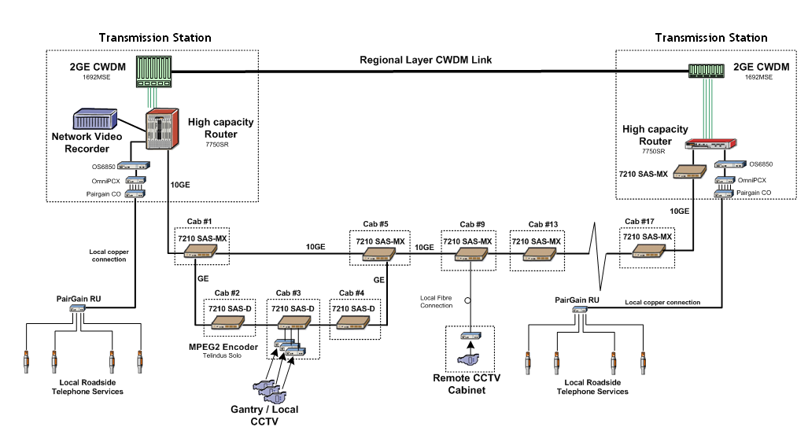
Figure 1 - Managed Motorways Lite Schematic Diagram

Section 2: Service Impacts

Service Impacts
The following 11 services will be supported by the OSS solution for Managed Motorways Lite. They will all be delivered in the IAMS phase.
Service Type Name |  | Location of SDP | Description of Service | “UP” SDP | “DOWN” SDP
1. | ST8RH | 7210SAS-M or 7210SAS-D | Non Diverse IP Service | SDP8RH-1 | SDP 8RH-2
2. | ST8RDH | 7210SAS-M or 7210SAS-D | Diverse IP Service | SDP8RDH-1 | SDP8RDH-2
3. | ST8RC2 | 2-port copper Solo | Non Diverse IP Service | SDP8RC2-1 | SDP8RC2-2
4. | ST8RCO1 | 1-port fibre Solo | Non Diverse IP Service | SDP8RC01-1 | SDP8RC01-2
5. | ST8RCO2 | 2-port fibre Solo | Non Diverse IP Service | SDP8RC02-1 | SDP8RCO2-2
6. | ST8RCO2D | 2-port fibre Solo | Diverse IP Service | SDP8RCO2D-1 | SDP8RCO2D-2

Service Type Name |  | Location of SDP | Description of Service | “UP” SDP | “DOWN” SDP
1. | ST10C2 | 2-port copper Solo | CCTV Switched Video – non diverse |  | SDP10C2-1
2. | ST10C2D | 2-port copper Solo | CCTV Switched Video - diverse |  | SDP10C2D-1
3. | ST10CO1 | 1-port fibre Solo | CCTV Switched Video – non diverse |  | SDP10CO1-1
4. | ST10CO2 | 2-port fibre Solo | CCTV Switched Video – non diverse |  | SDP10CO2-1
5. | ST10CO2D | 2-port fibre Solo | CCTV Switched Video - diverse |  | SDP10CO2D-1

Note: in some minor Transmission Stations, Digital Video Recorders may need to be moved from 7750s to 7210SAS-Ms. But since Digital Video Recorders are not part of any service definition in Circee, this will not affect any services in the OSS system.

Service Type ST8RH
Service Category 8 refers to IP services.
  - R stands for Road
  - D stands for Diverse (resilient equipment)
  - H stands for Hardened (environmentally hardened equipment).
Service type ST8RDH can be defined as an Ethernet Port Provision on a 7210SAS-M or a 7210SAS-D. Note: the service is offered off 1 GE optical and electrical interfaces on SAS-M and SAS-D routers.
The SDP is the port on the SAS-D (as per Figure 2 – Service Type ST8RH offered by a 7210SAS-D below).
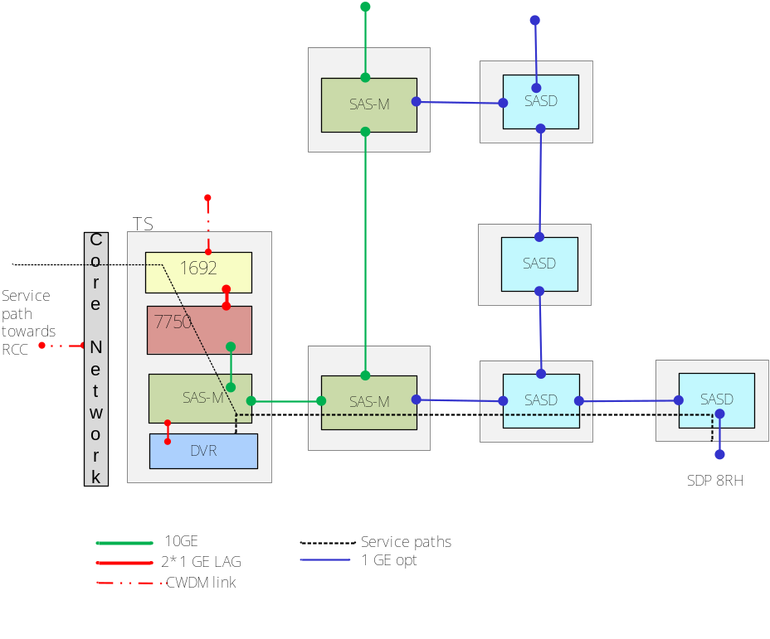
Figure 2 – Service Type ST8RH offered by a 7210SAS-D

Service type ST8RDH
Service Category 8 refers to IP services.
  - R stands for Road
  - D stands for Diverse (resilient equipment)
  - H stands for Hardened (environmentally hardened equipment).
Service type ST8RDH can be defined as an Ethernet Port Provision on a 7210SAS-M or a 7210SAS-D. Note: the service is offered off 1 GE optical and electrical interfaces on 7210SAS-M and 7210SAS-D routers
The SDP is the port on the SAS-D (as per Figure 3 - Service Type ST8RDH Offered via 7210SAS-D below) or the SAS-M (as per Figure 4 – Service Type ST8RDH offered by a 7210SAS-M below).
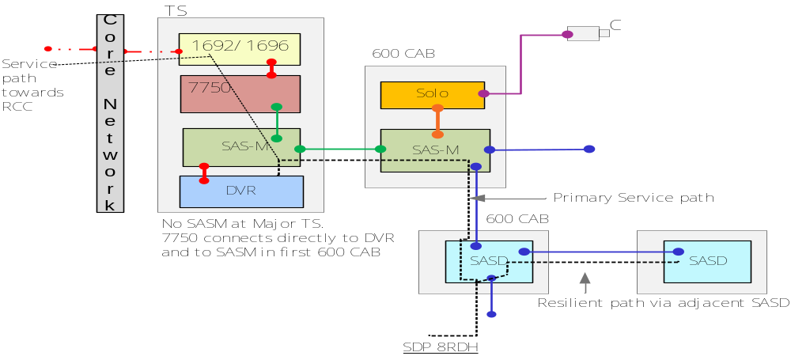
Figure 3 - Service Type ST8RDH Offered via 7210SAS-D

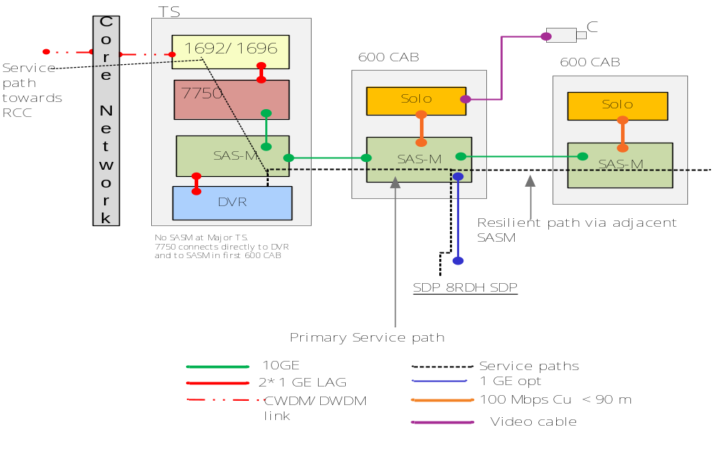
Figure 4 – Service Type ST8RDH offered by a 7210SAS-M

Service TYPE ST8RC2
Service Category 8 refers to IP services.
- R stands for Road,
- C2 stands for Codec
- 2 stands for 2-port Copper.
Service type ST8RC2 can be defined as an Ethernet Port Provision on a 2-port Copper Solo. Note:
- Service is offered off the electrical interface on a Telindus Solo MPEG-2 Encoder.
- Includes IP traffic for PTZ cameras.
The SDP port is on the Telindus Solo MPEG-2 Encoder.
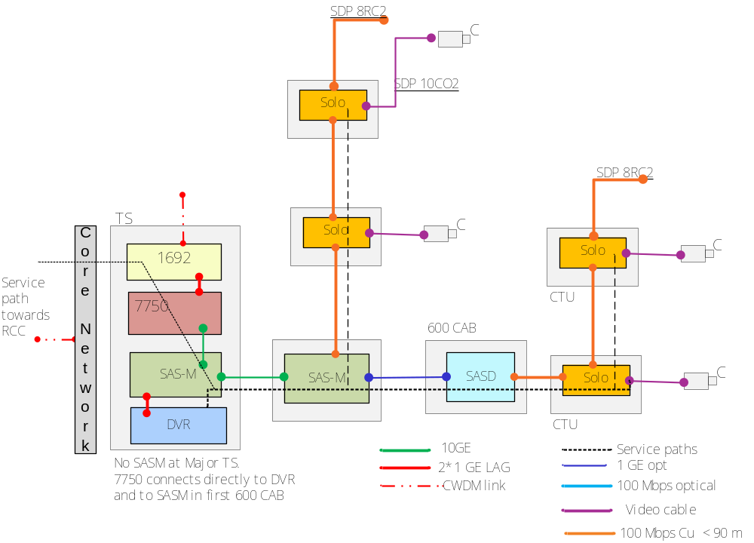
Figure 5 – Service Type ST8RC2 offered by a 2-port copper Solo

Service Type ST8RCO1
Service Category 8 refers to IP services.
- R stands for Road,
- C stands for Codec
- 01 stands for 1-port Fibre.
Service type ST8RCO1 can be defined as an Ethernet Port Provision on a 1-port Fibre Solo Telindus Encoder. Note:
- Service is offered off optical and electrical interfaces on Telindus Solo MPEG-2 Encoder.
- Includes IP traffic for PTZ cameras.
- Offered by subtended Solos, hence are not resilient.
The SDP port is on the Telindus Solo MPEG-2 Encoder.
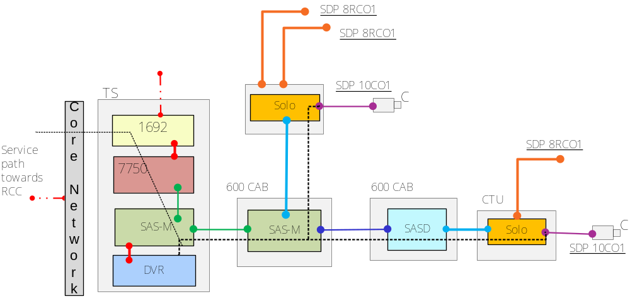
Figure 6 – Service Type ST8RCO1 offered by a 1-port fibre Telindus Solo MPEG-2 Encoder

Service Type STRCO2
Service Category 8 refers to IP services.
- R stands for Road,
- C stands for Codec
- 02 stands for 2-port Fibre.
Service type ST8RCO2 can be defined as an Ethernet Port Provision on a 2-port Fibre Solo Telindus Encoder. Note:
- Service is offered off optical and electrical interfaces on Telindus Solo MPEG-2 Encoder.
- Includes IP traffic for PTZ cameras.
- Offered by subtended Solos, hence are not resilient.
The SDP port is on the Telindus Solo MPEG-2 Encoder.
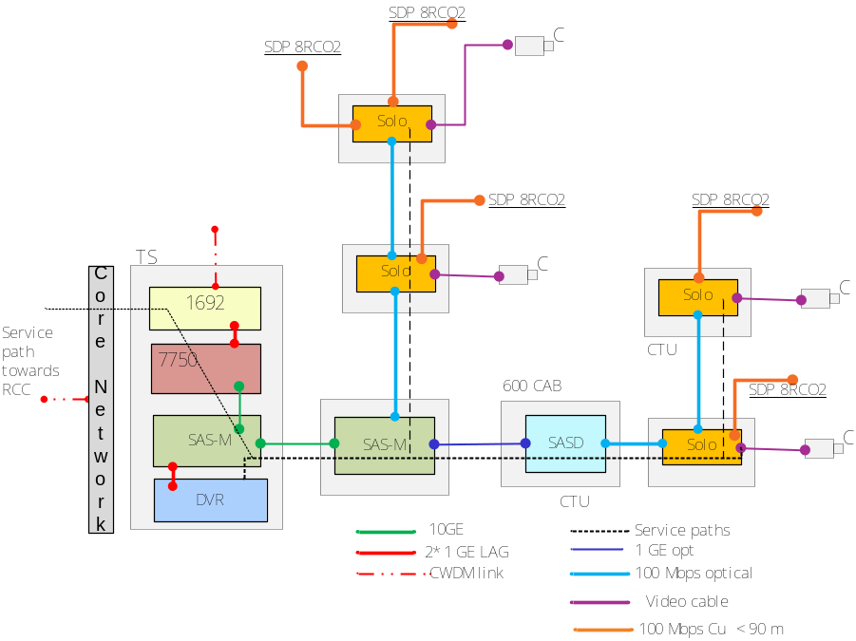
Figure 7 – Service Type ST8RCO2 offered by a 2-port fibre Solo

Service Type ST8RCO2D
Service Category 8 refers to IP services.
- R stands for Road,
- C stands for Codec
- 02 stands for 2-port, Fibre
- D stands for Diverse.
Service type ST8RCO2D can be defined as a Diverse Ethernet Port Provision on a 2-port Fibre Solo Telindus Encoder. Note:
- Service is offered off optical and electrical interfaces on Telindus Solo MPEG-2 Encoder.
- Includes IP traffic for PTZ cameras.
- Diverse (i.e. resilient service).
The SDP port is on the Telindus Solo MPEG-2 Encoder.
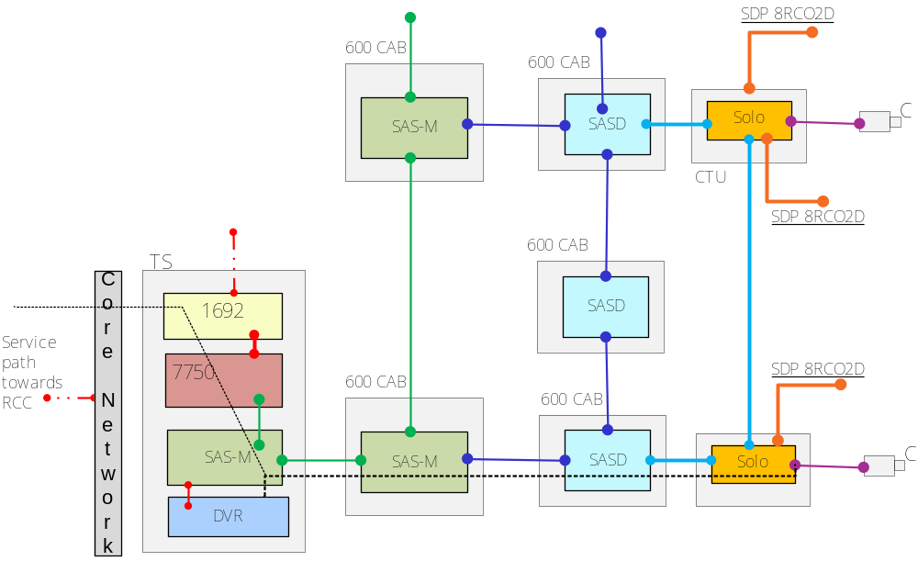
Figure 8 – Service Type ST8RC02D offered by a 2-port fibre Solo

Service type ST10C2
Service Category 10 refers to CCTV Switched Video services.
- C stands for CODEC
- 2 stands for 2-port, Copper
For ST10C2, CCTV video is supported by a copper cable infrastructure; it provides a 2 Ethernet port variant copper based Telindus Solo MPEG-2 Encoder Codec within the equipment cabinet.
The SDP location is the BNC connector on the solo; the configuration is non-resilient.
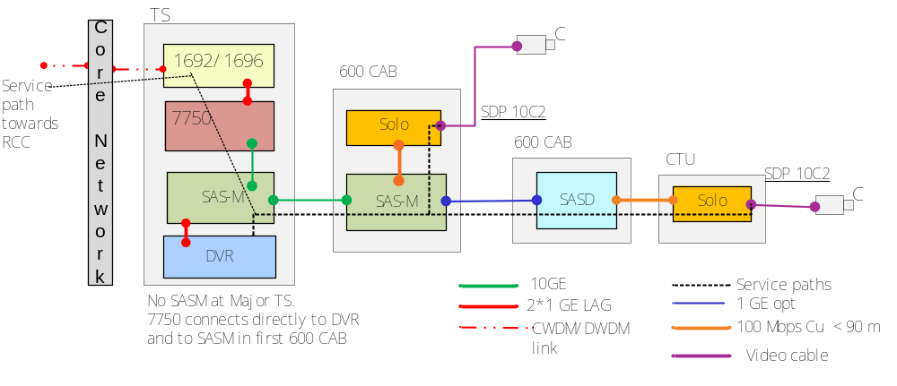
Figure 9 – Service Type ST10C2 offered by a single 2-port copper Solo

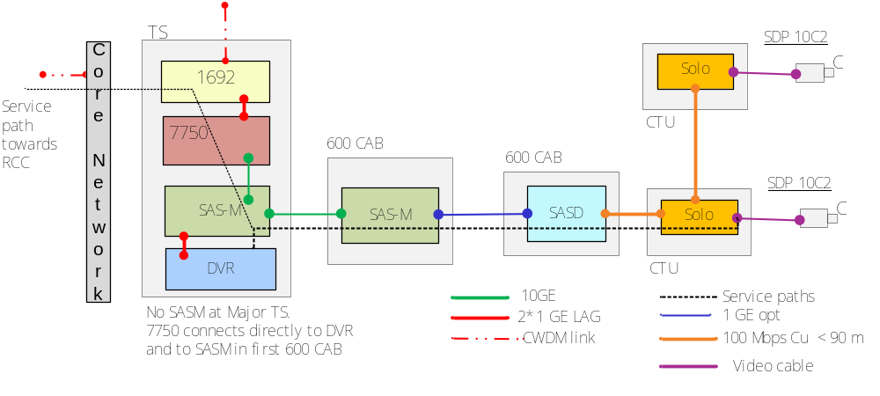
Figure 10 – Service Type ST10C2 offered by a 2-port copper Solo on in a chain

Service Type ST10C2D
Service Category 10 refers to CCTV Switched Video services.
- C stands for CODEC
- 2 stands for 2 Port, Copper
- D stands for Diverse.
For ST10C2D, CCTV video is supported by a fibre cable infrastructure; it provides a 2 Ethernet port variant copper based Telindus Solo MPEG-2 Encoder Codec within the equipment cabinet.
The SDP location is the BNC connector on the solo; the configuration is resilient.
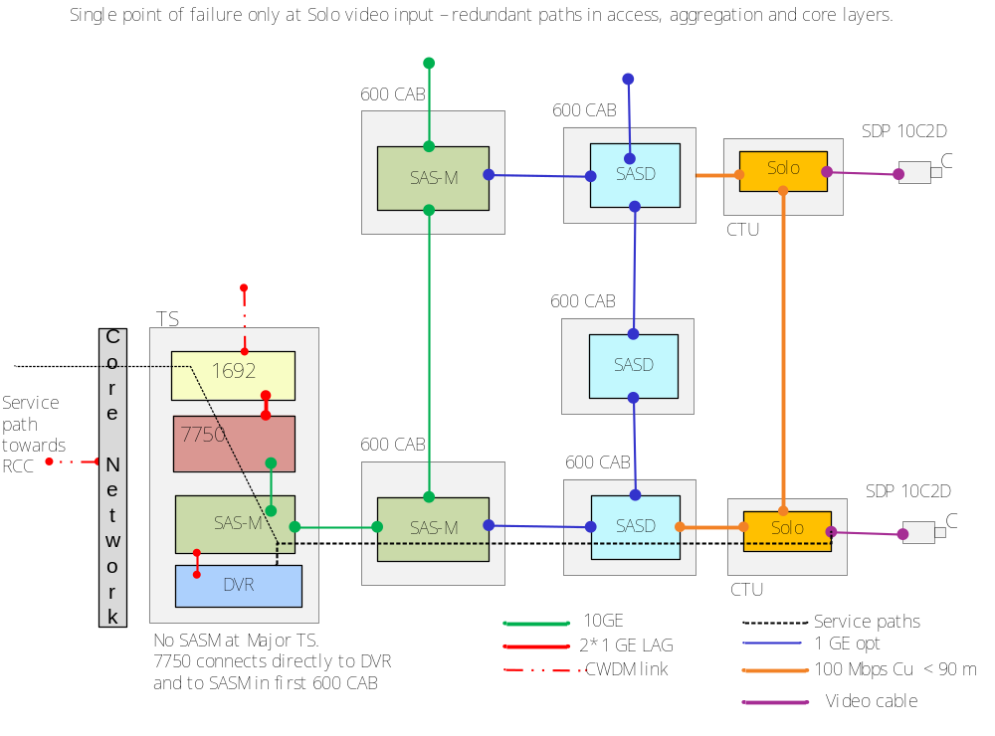
Figure 11 - Service Type ST10C2D offered by a 2-port copper Solo

Service Type ST10C01
Service Category 10 refers to CCTV Switched Video services.
- C --> stands for CODEC
- 01 --> Stands for 1 Port, Fibre.
For ST10C01, CCTV video is supported by a fibre cable infrastructure; it provides a one optical port variant fibre based Telindus Solo MPEG-2 Encoder Codec within the equipment cabinet.
The SDP location is the BNC connector on the solo.
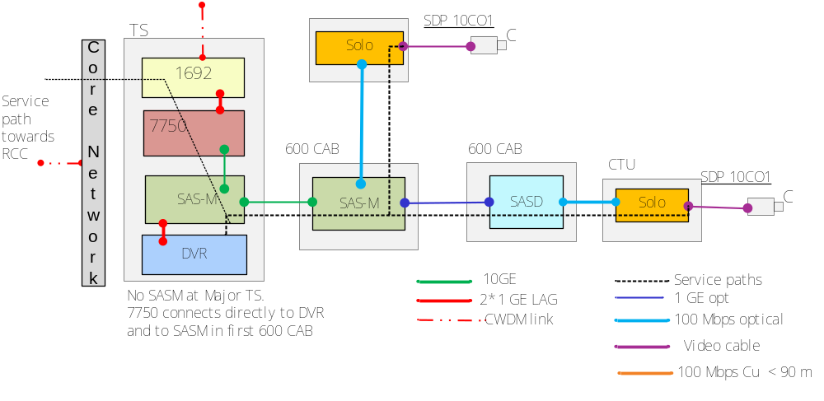
Figure 12 – Service Type ST10C01 offered by a 1-port fibre Solo

Service Type ST10C02
Service Category 10 refers to CCTV Switched Video services.
- C --> stands for CODEC
- 02 --> Stands for 2 Ports, Fibre.
For ST10C02, CCTV video is supported by a fibre cable infrastructure; it provides a two optical port variant fibre based Telindus Solo MPEG-2 Encoder Codec within the equipment cabinet.
The SDP location is the BNC connector on the solo.
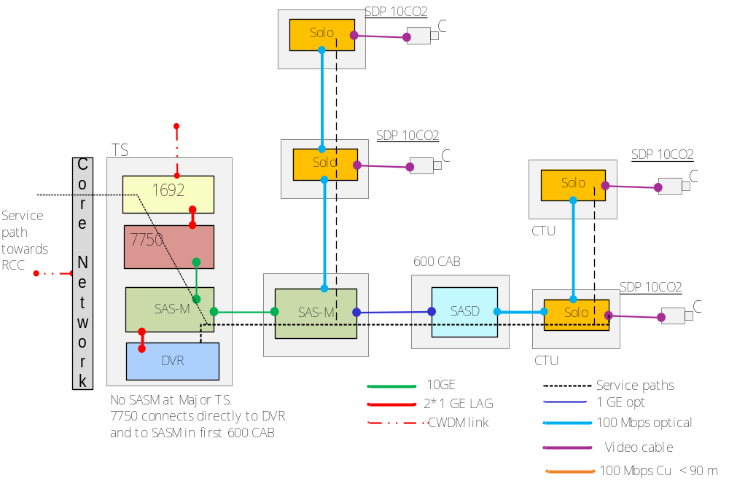
Figure 13 - Service Type ST10C02 offered by a 2-port fibre Solo

Service Type ST10C02D
Service Category 10 refers to CCTV Switched Video services.
- C --> stands for CODEC
- 02 --> Stands for 2 Ports, Fibre
- D stands for Diverse.
For ST10C01, CCTV video is supported by a fibre cable infrastructure; it provides a two optical port variant fibre based Telindus Solo MPEG-2 Encoder Codec within the equipment cabinet.
The SDP location is the BNC connector on the solo.
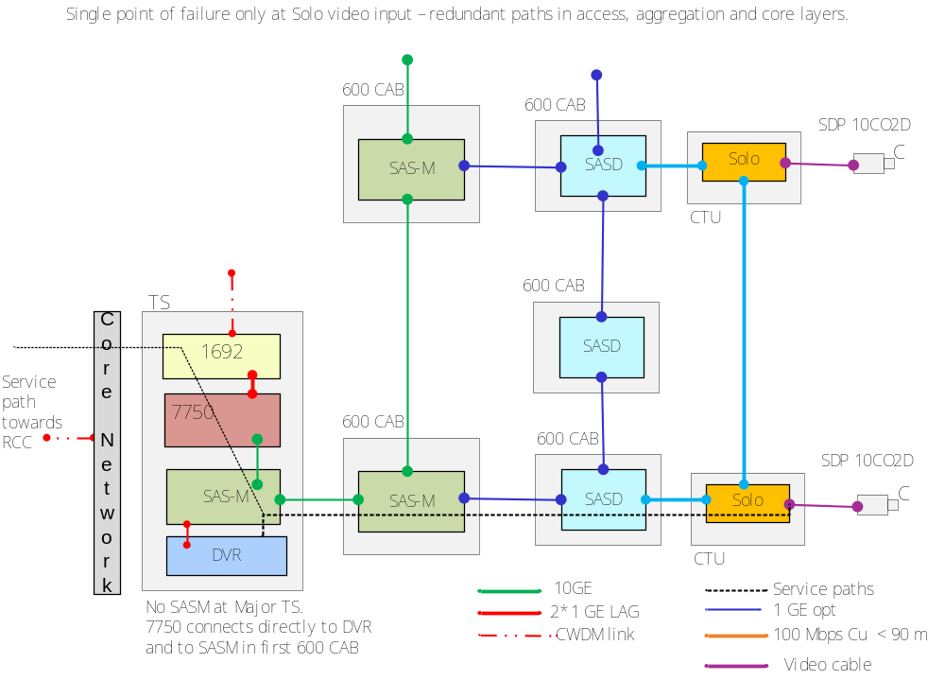
Figure 14 - Service Type ST10C02D offered by a 2-port fibre Solo

Section 3: System Architecture

System Architecture

System Functional Architecture
Whilst there will be no change to the functional architecture of the overall OSS solution, some of the subsystems will be impacted. Section 4.1.1 below shows the functional architecture and interfaces involved in the end-to-end OSS solution. It also shows the subsystems that will be impacted by this work pack, such that their set of capabilities will be extended in support of Managed Motorways Lite.

Functional Architecture Diagram
The Diagram below shows the functional architecture of the OSS system. Note that:
- Objects with red outline indicate subsystems changed at the IAMS Phase, and possibly at the Full Solution phase.
- Objects with yellow outline indicate subsystems to be changed at the Full Solution phase only.
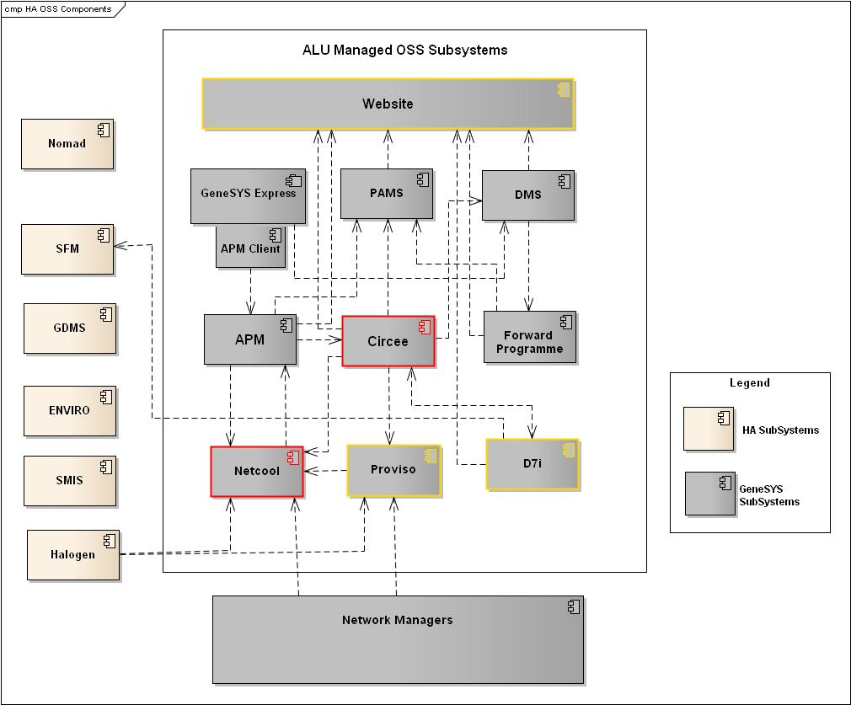
Figure 15 - Functional Architecture Diagram - Managed Motorways Lite

Description of System
The composition of the NRTS OSS is as illustrated above in Figure 15 - Functional Architecture Diagram - Managed Motorways Lite. Four sub-systems will be extended for MMLite: Netcool, Proviso, Circee and D7I; only the Netcool and Circee changes are in scope for MMLite IAMS.
Proviso, D7I and Website changes will be dealt with in Phase 3, plus any further changes to Netcool and Circee.

Subsystem Functional Architectures

Netcool Functional Changes
Functional changes to Netcool are identified by Figure 16 - Netcool Functional Changes. The Red outline colour indicates a subsystem is to be changed at the IAMS phase.
Any changes made to the components shown in red will need to be reflected in the DRC.
Note that this solution is based on version 9 of the SAM 5620 Element Manager.
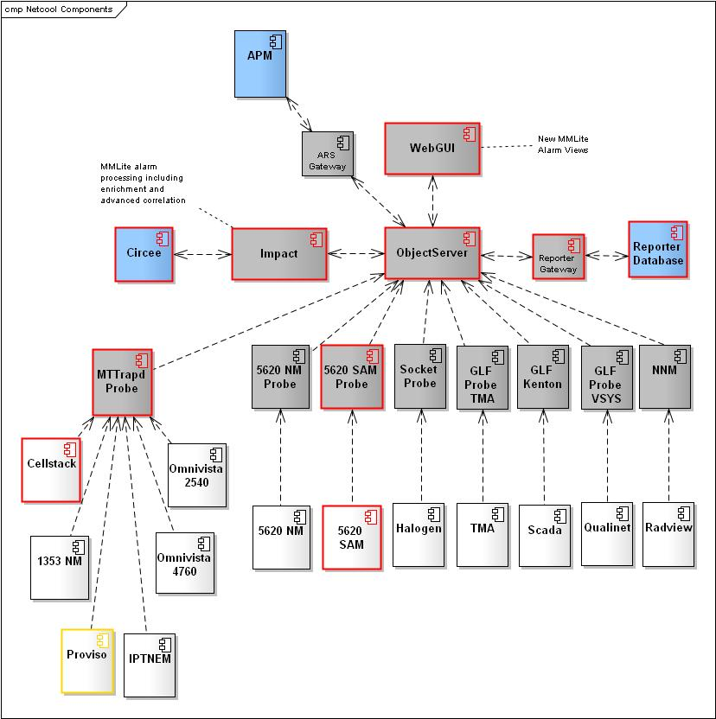
Figure 16 - Netcool Functional Changes
To provide the fault management capability in line with the SoR and the MMLite project specific requirements, the following changes will be made to the Netcool deployment. A number of new alarms will be introduced as a result of the MMLite deployment. These alarms are documented in appendix section 7.

Alarm Capture and Handling

The 5620 SAM probe rules file and look up files will need to be updated to ensure the following events are captured, formatted and processed:
- Alarms coming from the new 7210SAS-M and 7210SAS-D (via the 5620 Sam element manager);
- Alarms from the Telindus Solo MPEG-2 encoders, (generated by Cellstack, which sends them to the Mttrapd probe) are already being captured. Although the encoders are different variants to the ones already used in the network, their alarms remain the same. Hence no changes are needed in the Mttrapd probe or other Netcool components to capture them. However, some changes may be needed to the lookup tables in order to inhibit trouble ticket creation. (Please see Outage Triggers Section 3.2.1.9).

The 5620 Sam probe will be updated to ensure that event de-duplication and alarm clearing processing for Managed Motorways Lite alarms is fully supported.
The managed object names of the alarming components will be used as one of the fields to uniquely identify the alarms and will support alarm de-duplication.
The problem and corresponding resolution alarms will be identified in the alarm list. Where resolution alarms are not identified, appropriate expiry times will be set up for alarms.
Only alarms defined in the Outage Triggers (please see section 3.2.1.9) will automatically raise trouble tickets. The STIs affected by an outage will be made immediately visible using Netcool views.
For the IAMS phase, 25 potentially Service-Affecting Alarms will be processed by Netcool (see section 7). These 25 alarms were identified by Alcatel and agreed upon by Fluor as being the only potentially service affecting alarms for the 7210SAS-Ms and 7210SAS-Ds.The remaining alarms from the 7210SAS-Ms and 7210SAS-Ds will be processed in the Full solution (Phase 3).
For the IAMS phase, any alarms coming from the 7210SAS-Ms and 7210SAS-Ds which are not present in the IAMS Alarm List will be stored in Netcool, but will not be visible in the standard views (See section 3.2.1.3).
It will be possible to identify an alarm as an SPCE alarm at the Netcool display level.

Alarm Enrichment
The existing Netcool Impact policies will be used to enrich the new alarms coming from the 7210SAS-Ms and 7210SAS-Ds. As per the current capability, service affecting alarms will be enriched with STI impact details.
Netcool is already receiving alarms from copper, 1-port variants of Telindus Solo MPEG-2 Encoders. MMLite introduces 2-port copper variants, and 1 and 2-port fibre variants. The alarms from this new equipment will remain the same, although they will be handled differently (for example with respect to outage triggers).
Each alarm will also be enriched with the geographical location of the asset it relates to.

Circee fields SYSTEM_TYPE and STI_HA_IMPACT
Alarms from the Telindus Solo MPEG-2 Encoders will be enriched with the values of two fields from Circee (for more details on these fields, see section 3.2.2.2):
- Field SYSTEM_TYPE, in table End_Device, (a value, “HSM”, in this field, identifies cameras used to monitor hard shoulders);
- Field STI_HA_IMPACT, in table STI. (This field categorises STIs according to importance to the Highways Agency).
The Netcool alarms are already enriched with the value of field STI_HA_IMPACT.
A new field will need to be created for the alarms (i.e. in table alerts.status in the ObjectServer) so that they can be enriched with the value of SYSTEM_TYPE.
Note that these two fields will also need to be propagated to the Reporter database. This is already the case for STI_HA_IMPACT. However, the field enriched with the value of SYSTEM_TYPE will need to be created in the Reporter database, and the configuration of the Oracle gateway will need to be amended so that the value of this field is also transferred across.

WebGUI Configuration for IAMS
Netcool WebGUI views will be created to display Managed Motorway Lite (SPCE) alarms in line with NOC requirements:
- A view to display all SPCE-only alarms coming from the new 7210SAS-M, 7210SAS-D service access switches and the Telindus Solo MPEG-2 Encoders.
- A view to display all service-affecting SPCE-only alarms (as per outage triggers). The columns containing the values of STI_HA_IMPACT and SYSTEM_TYPE will be present in this view.
- A view to display all SPCE-only alarms relating to hard shoulder cameras
- A view to display all SPCE-only alarms which are not service-affecting.

ObjectServer
A new field will be added to table alerts.status, so that SPCE alarms coming from Telindus Solo MPEG-2 Encoders can be enriched with the value of field SYSTEM_TYPE held in the END_DEVICE table in Circee.

Reporter Database
The new field mentioned in section 3.2.1.4 above will need to be created in the equivalent table in the Reporter Database.

Reporter gateway
The gateway will need to be amended in order to update the field mentioned in section 3.2.1.5 above.

ObjectServer gateway
The gateway between the main ObjectServer and the ObjectServer in he DRC will need to be amended in order to update the field mentioned in section 3.2.1.5 above.

Parent/Child correlation
This will be covered in Phase 3.

Outage Triggers
Automatic trouble tickets with reflective STI information will be created in response to the outage triggers defined in this section.
The outage triggers identified below will cover the most common causes of STI outages. Note that outages in the core and aggregation layer are not likely to result in service outages on account of the resilience built into MMLite. Hence the IAMS outage triggers are based primarily on failures that affect devices in the access layer.

The outage triggers can be divided according to whether the service resides on a7210 or on a Telindus Solo MPEG-2 encoder.

Services residing on 72SAS-Ms or 7210SAS-Ds
Two outage Scenarios have been identified for service 8:
- Loss of a link
- Equipment Isolation.
In both cases, an outage will only be caused in the case of loss of a link directly connecting the 7210SAS-M or 7210SAS-D to a Service Category 8 end device (as illustrated by the red arrows in Figure 17 - Service Category 8 Outage Triggers). If, on the other hand, the port is a pass-through point (as illustrated by the green arrows), no outage trigger will be raised. In this example, any outage to IPT triggers would be covered by the IPT (WP190) work stream.
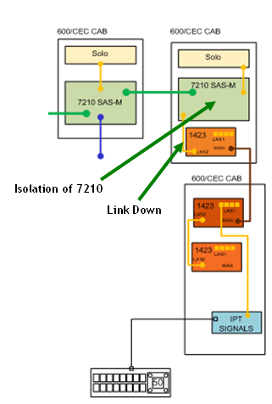 | 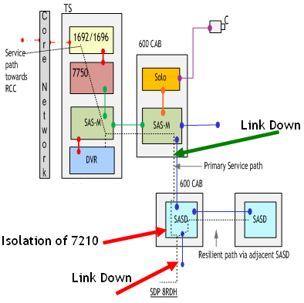
Figure 17 - Service Category 8 Outage Triggers

List of outage scenarios and triggers:
1. Loss of Link from 7210
- Trigger1
  - LinkDown alarm received from SAM 5620 Element Manager for a 7210SAS-M or a 7210SAS-D from a port that has a ST8RH or ST8RDH end device directly attached to it.
- output
  - Automated Trouble Ticket generated in APM enriched with detail of all STIs affected;
- Trigger2
  - EquipmentDown alarm received from SAM 5620 Element Manager for a 7210SAS-M or a 7210SAS-D from a port that has a ST8RH or ST8RDH end device directly attached to it.
- output
  - Automated Trouble Ticket generated in APM enriched with detail of all STIs affected;
- Trigger3
  - ContainingEquipmentOperationallyDown alarm received from SAM 5620 Element Manager for a 7210SAS-M or a 7210SAS-D from a port that has a ST8RH or ST8RDH end device directly attached to it.
- output
  - Automated Trouble Ticket generated in APM enriched with detail of all STIs affected;

2. Node Isolation
If a 7210 is isolated, then the OSS must examine all its links. If there is a link to a Service Category 8 end device, this means the corresponding STI has gone down.
- Trigger4
  - ReachabilityProblem alarm received from SAM 5620 Element Manager for a 7210SAS-M or a 7210SAS-D. One of the remote links is an ST8RH or ST8RDH end device.
- output
  - Automated Trouble Ticket generated in APM enriched with detail of all STIs affected;

Services that reside on Solos
It is important to note that the Telindus Solo MPEG-2 Encoder does not support interface alarms. Figure 18 - loss of link to control port of camera below illustrates the following links:
- Link between the port on the Solo and the control port on the camera;
- Link between the BNC connector on the Solo and the video output in the camera;
- Link between the port on the Solo and the port in the 7210.
In a situation where the link between the Ethernet port on the Solo and the control port on the camera goes down, but the remaining two links stay up, no alarm will be generated. Consequently, there will be no outage trigger. The fault will only become apparent when an operator tries to send a control signal to the camera and finds that it is not responding.
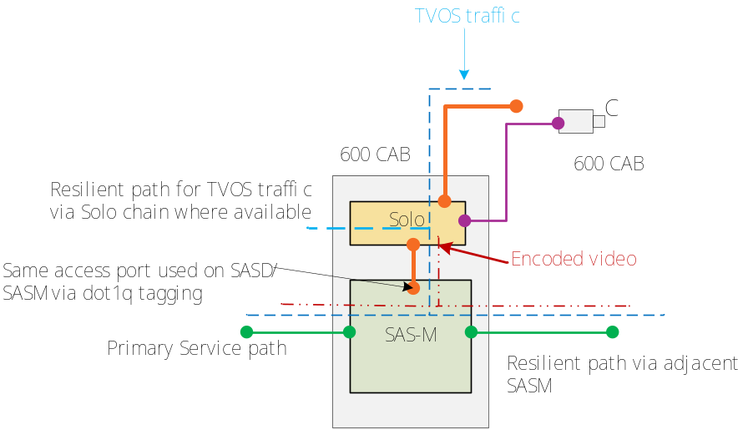
Figure 18 - loss of link to control port of camera
When considering outage triggers for services that reside on the Solos, there is no need to be concerned with 7210SAS-M or 7210SAS-D alarms. A service outage condition is represented by one of two alarms generated by the Cellstack element manager: either a camera is lost or there is an isolation of the Solo. These two conditions are represented in the diagram below:
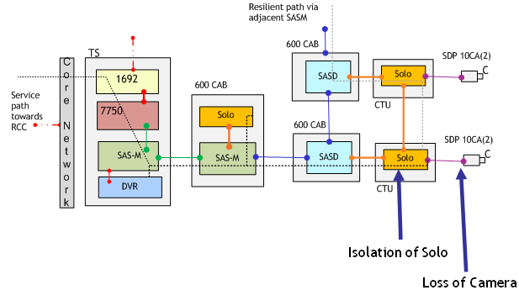
Figure 19 - Service Category 10 Outage Triggers
List of scenarios and triggers :
1. Telindus Solo MPEG-2 Encoder isolated:
- Trigger 5
  - csNmsTrapLossOfConnection alarm received from Cellstack element manager
- output
  - Automated Trouble Ticket generated in APM enriched with detail of the STI affected;
2 Camera lost:
- Trigger 6:
  - BoardNoVideoSync alarm received from Cellstack element manager
- output
  - Automated Trouble Ticket generated in APM enriched with detail of the STI affected;

Circee Functional Changes

Circee Requirements Mapping
To support the Management Motorway deployment, the following requirements have been identified. The full list of requirements including deferred and obsolete requirements can be found in section 7.1
Business Requirements | Functional Requirements
BR495: The solution shall allow a QDT User to create, read, update and delete all the new Passive Telecom Infrastructure (e.g. Cables, Fibres) required to manage the new network equipment. | No New FRs – existing functionality
BR498: The solution shall allow the creation of new configurations of Infrastructure (e.g. attributes implemented via Asset Templates). | FR582: New catalogue items and templates shall be created within the Inventory Management system for the 7210SAS-M. There is an AC variant and a DC variant.  AC variant:  o 1GE_SFP port (occurs 24 times)  o 10GE_XFP port (occurs 2 times)  o PSU Port  o Console Port  o Management Port  o FAN  o AC PSU  The DC variant is identical to the AC variant described above, apart from the fact that the last item will be a DC PSU rather than an AC PSU.  Both the AC variant and the DC variant may optionally have an MDA with two 10GE_XFP ports.
FR662: New catalogue items and templates shall be created within the Inventory Management system for the 7210SAS-D. Unlike the 7210SAS-M, the 7210SAS_D will always have the same attributes, as there are no variants or optional extras.
o 1GE_SFP port (occurs 6 times)
o 1GE_BTX port (occurs 4 times)
o Console_Port
o PSU_Port
 | FR663: A new template needs to be created for the Copper-based Telindus Solo MPEG-2 encoder with two ports. Catalogue items and a template already exist in the Inventory Management system for the Copper-based Telindus Solo MPEG-2 encoder with one port.
FR664: A new catalogue item (Optical fast port) and templates shall be created within the Inventory Management system for the fibre-based Telindus Solo MPEG-2 Encoder. There are two variants.

Single port variant:
o LAN port (occurs twice)
o Optical Fast Ethernet port
o Video in port
o Console data port (occurs twice)
The two port variant will have an extra Optical fast Ethernet port
BR497: The solution shall allow a QDT User to create, read, update and delete all the new Services to be delivered over the Network. | FR583: The existing functionality of the Service Schedule within the Inventory Management system (which allows creation, modification and deletion of Service Type Instances) shall be extended to the following new Service Types:  - ST8RH  - ST8RDH  - ST8RC2  - ST8RCO1  - ST8RCO2  - ST8RCO2D  - ST10C2  - ST10C2D  - ST10CO1  - ST10CO2  - ST10CO2D
BR500: The solution shall support updates to the Service Templates based on the agreed Infrastructure Scenarios (including topology - to be agreed during design). | FR587: The existing functionality of the inventory system which allows each Service Type Instance to include the links between the ports in each corresponding device shall be extended to the Service Types listed below:  - ST8RH  - ST8RDH  - ST8RC2  - ST8RCO1  - ST8RCO2  - ST8RCO2D  - ST10C2  - ST10C2D  - ST10CO1  - ST10CO2  - ST10CO2D
BR501: The agreed Infrastructure Scenarios shall be documented within the Service Template. | FR588: The system shall support representation of the Infrastructure Scenarios within the Service Templates.
BR502: The solution shall provide the geographic location for all new Infrastructure items, and display the site where they are located on the GIS maps. | FR589.1: The existing functionality of the inventory system holds the GIS for each asset shall be extended to include the new equipment types, i.e.:  o 7210 SAS-M  o 7210 SAS-D  o Telindus Solo MPEG-2 Encoder - 2 port optical based Solo  o Telindus Solo MPEG-2 Encoder - 2 port optical based Solo  o Telindus Solo MPEG-2 Encoder - 2 port copper based Solo
BR503: The solution shall have any new Service Types modelled within the Service Schedule, prior to delivery of the OSS Solution. | FR583: The existing functionality of the Service Schedule within the Inventory Management system (which allows creation, modification and deletion of Service Type Instances) shall be extended to the following new Service Types:  ST8RH  ST8RDH  ST8RC2  ST8RCO1  ST8RCO2  ST8RCO2D  ST10C2  ST10C2D  ST10CO1  ST10CO2  ST10CO2D
BR504: The solution shall allow an Active Telecom Infrastructure item to be uniquely identifiable, regardless of location. | FR590: Each Active Telecom asset shall have a unique identifier within the Inventory Management system. Note that location may be a component of the Identifier, but it shall always be just a component of the identifier.
BR580: The System shall enrich alarms to allow the HA to differentiate between MMLite specific service outages and other service outages (for example, camera going down on the hard shoulder as opposed to an ordinary traffic monitoring camera). | FR673: The solution shall allow the user to record assets related to critical services (e.g. Hard Shoulder Monitoring (HSM) camera) via the GUI.
Table 3 - Circee Requirements Coverage

Circee Change Description
To provide the required support for Inventory and Asset Management processes, the following changes are required to be made in Circee.
- The Creation of new active equipment templates
The table below lists the equipment catalogue items and templates which will be required in Circee to support the Managed Motorways Lite deployment. Further details of the components required for the template can be found in the accompanying Circee Asset Template spreadsheet [8].
Equipment Catalog Items | Equipment templates
7210SAS Component  1. 7210_SAS_1GE_SFP  2. 7210_SAS_1GE_BTX  3. 7210_SAS_10GE_XFP  4. 7210_SAS_Mngt_Port  5. 7210_Con_Port  6. 7210_SAS_MDA_2X10GE  7210 SAS-M specific component  7. 7210SAS-M_Subrack  8. 7210SAS-M_FAN  9. 7210SAS-M_AC_PSU  10. 7210SAS-M_DC_PSU  11. 7210SAS-M_PSU_Port  7210SAS-D specific component  12. 7210SAS-D_Subrack  13. 7210SAS-D_PSU_Port  Cellstack Solo  13. Solo_Subrack (already exists) *  14. Solo_S_Subrack  15. Solo_S_SO_Subrack  16. Solo_S_DO_Subrack  18. Solo_Video Port  19. Solo_Optical_Port  2o. Solo_Console_Port  21. Solo_LAN_Port (already exists) | 1. 7210_MDA_2X10GE  2. 7210SAS-M_AC  3. 7210SAS-M_AC_MDA  4. 7210SAS-M_DC  5. 7210SAS-M_DC_MDA  6. 7210_SAS-D  7. Solo_Subrack (already exists) *  8. Solo_S_Subrack  9. Solo_S_SO_Subrack  10. Solo_S_DO_Subrack
* Please note that the catalog items Solo_Subrack and Solo_Port and the template Solo_Subrack already exist from previous work packages, but they are being listed here for completeness.
Table 4 - Catalogs and Templates
- Updates to Circee will be required to support the new service types below. These services will be available as service type option.
- Updates to the topology tables (including L1 and L2 tables) to support the new network topology and infrastructure scenarios. The content and data format will be documented in the low level design documentation.
- Provision of service templates which reflects the infrastructure scenarios.
- When cameras are created, one of the fields that currently needs to be populated is SYSTEM_TYPE. (This field is on the END_DEVICE table in Circee). In the Circee GUI, there is a drop down list of values for this field. A new value, “HSM”, has been added to this drop down list. This is the value that must be used during data entry for SYSTEM_TYPE every time a camera that is to be used for hard shoulder monitoring is created.
- Additionally, each STI record has a field called STI_HA_IMPACT. This field currently defaults to 1, and this is the value that all STIs in the system currently hold. The Highways Agency will define rules for the population of this field in order to define priorities for STIs. Currently, a need has been identified to categorise STIs that involve hard shoulder cameras, according to the type of road they are used to monitor. As and when new requirements for such categorizations are identified, the Highways Agency will amend the rules for populating this field accordingly.
- Both the SYSTEM_TYPE and STI_HA_IMPACT fields can already be populated via the Circee GUI.
- Bulk data population for STI, Asset, and Topology data is provided by Work Package 186, while Work Package 180 allows the bulk creation and updating of the Topology tables. The WP 186 scripts currently allow field SYSTEM_TYPE to be populated. They do not, however, allow population of field STI_HA_IMPACT. They will be amended as part of this work package in order to allow population of this field.

In Figure 20 - Circee Component Design Changes below, the areas affected by these changes are highlighted in red.
Any changes made to the components shown in red will need to be reflected in the DRC.

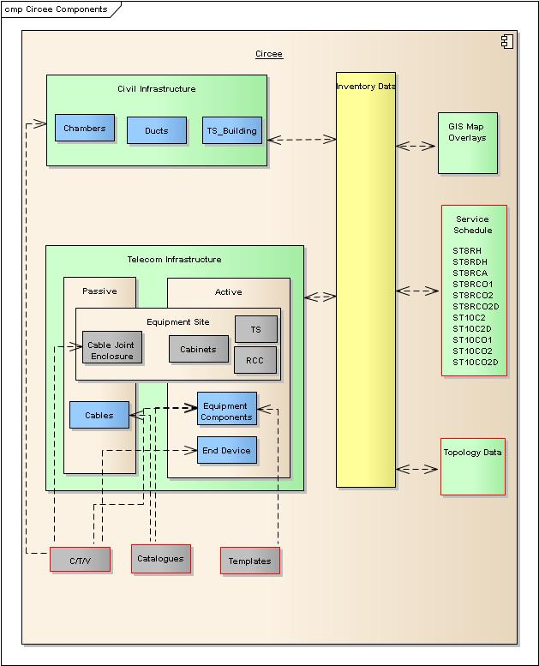
Figure 20 - Circee Component Design Changes

Circee Deliverables
The design deliverables from this work package are listed in the table below. While listed on separate rows, these may all be delivered as one patch:
- Circee patch to include support for new services
- Circee patch to include support for new devices and sub-components (templates)
- Supporting documentation

Circee Deliverable verification
The functionality delivered by work package 199 which has been described needs to be tested and verified.
The test cases should cover the following:-
- Full coverage of the requirements detailed in section 4.2.2.1
- Functionality providing support of modelling the new device, sub components and templates as detailed in the accompanying Circee Asset Templates spreadsheet [8].
The new service types below must be available for selection from Circee.
  - ST8RH
  - ST8RDH
  - ST8RC2
  - ST8RCO1
  - ST8RCO2
  - ST8RCO2D
  - ST10C2
  - ST10C2D
  - ST10CO1
  - ST10CO2
  - ST10CO2D.

MMLite Device naming Convention
The devices to be introduced will follow a naming convention which will allow the easy identification of the unique MMLite instances in the network. It will follow the general naming convention for the existing new build services in the network, with variations to allow the identification of MMLite devices.

SASM
M##SASMmmm/pp.##M# (e.g. M62SASM120/5h.01M1 ):
- M## = MM Lite (SPC E) scheme number, identified by the motorway it is predominantly associated with
- SASM = fixed value, device type
- mmm/pp = marker post value
- .## : device number, unique value for each device in a cabinet (as the marker post value may be the same). Default value 1 where only one device exists in a cabinet. Increment sequentially for additional SASMs within the cabinet.
- M# : SASM chain number, identifies a chain of SASMs that are part of the same resilience scheme. Currently the scenario most likely to occur is an MM Lite scheme where there is only one chain of SASMs supported by a single 10 GE backup link. This field is added only for future proofing for the unlikely scenario that a number of SASM chains exist within a given scheme with independent resilience schemes. This is required for OSS resilience policy implementation. Value 1 will be used as default when only a single resilience scheme exists. In the case of SASMs located in a Transition Station the value will be zero. The value will be incremented sequentially when required.

SASD
- M##SASDmmm/pp_M#Dd## .### (e.g. M62SASD130/5h_M1DW05.050):
- M## : as defined in section 3.2.2.5.1.
- SASD : fixed value, device type
- mmm/pp : as defined in section 3.2.2.5.1.
- M# : as defined in section 3.2.2.5.1.
- Dd## : where d = E or W, ## is a two digit integer, which together uniquely identify a chain of 7210SASDs within an MM Lite scheme. E and W refer to East or West of the scheme “midpoint” where traffic is split between the two TSs. Span numbers are chosen sequentially 1, 2, 3 …. etc.
- .### : where the two most significant digits are chosen at multiples of 5, the least significant digit is always 0 for a 7210SAS-D on a chain and 1 for a 7210SAS-D that is subtended e.g. a 7210SAS-D subtended off another 7210SAS-D numbered .250 will be numbered .251.

Solo
- M##SOLOmmm/pp_M#D##L##.# (e.g. M62SOLO130/5h_M1DW05L18.1 )
- M## : as defined in section 3.2.2.5.1
- SOLO : fixed value, device type
- mmm/pp : as defined in section 3.2.2.5.1
- M# : as defined in section 3.2.2.5.1
- D### : as defined in section 3.2.2.5.1. Additionally, in the case the Solo is directly attached to a SASM, ### is set to 000.
- L## : Solo chain identifier within an MM Lite scheme. Solo chains attached to a 7210SAS-M should also be given a unique identifier (see example diagrams).
- .## : device number, unique value for each device in a cabinet (as the marker post value may be the same). Default value 1 where only one device exists in a cabinet. Increment sequentially for additional Solos within the cabinet

Examples

SAS-M
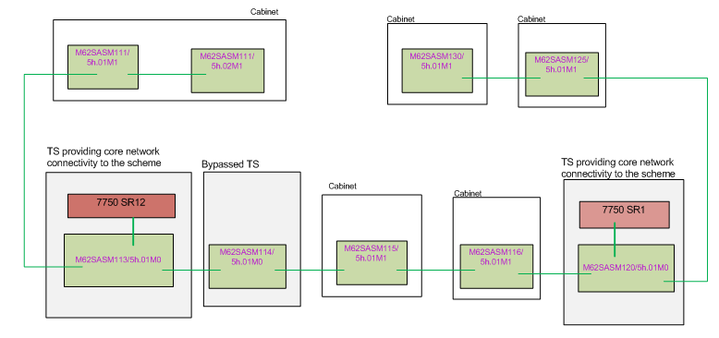
Figure 21 - naming examples – single 10 GE backup link across all SASMs is assumed

SAS-D
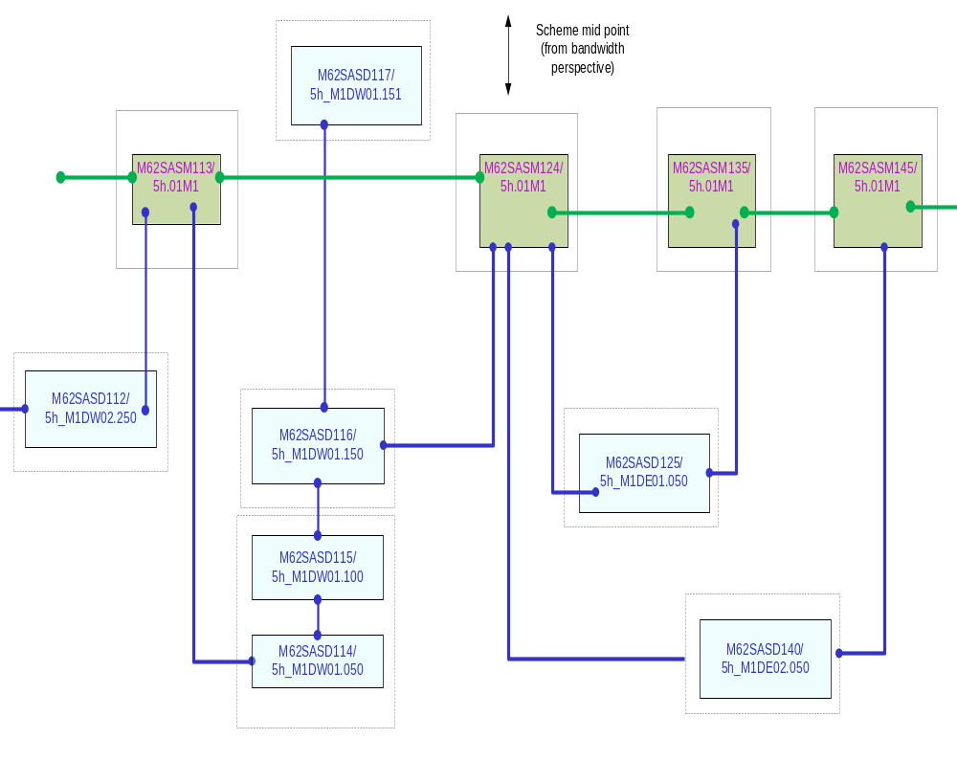
Figure 22 - SASD naming examples

SOLO
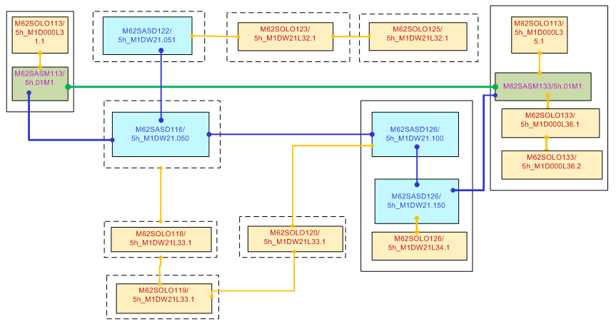
Figure 23 - SOLO naming examples

Data model

High Level Data Model

System Logical Data Model – End to End Work Pack View
The following diagram shows the databases resident in all OSS subsystems involved in the solution and the connectivity between them.
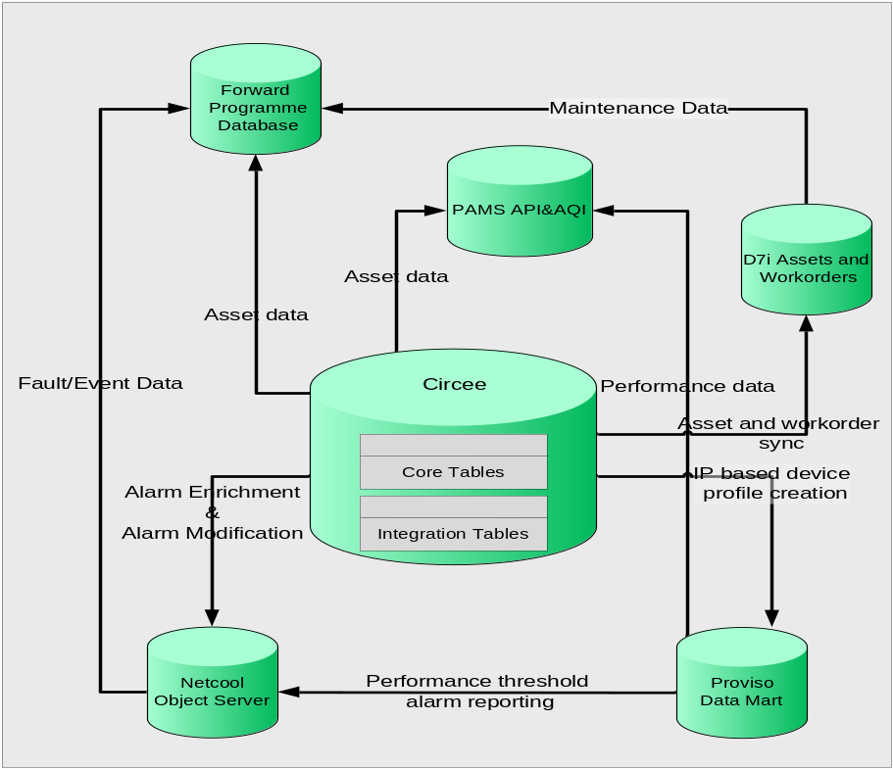
Figure 24 - High Level Data Model

The table below lists the data repositories that are shown in the figure above. The table provides a brief description of each and what changes are required as a result of this work package.

OSS Subsystem | Data Model Function | Work Package Changes
Netcool (ObjectServer and Reporter) | This in memory database which is deployed as part of Netcool serves as a repository for alarm and Netcool data. | There will be no change to the ObjectServer data model as part of this work pack.
Circee | The Circee data model stores asset, services and topology data. The database stores data which describes each type of asset and service in the form of catalogue items, templates and the service schedule. | There will be no change to the Circee data model. The appropriate tables will be updated with specific data to enable support for MMLITE assets and service. The tables to be updated will be detailed in the low level design documentation.
D7i Assets and Work Orders | The D7i database is an Oracle 9i database which holds all the asset and work order information. The asset data is populated by a scheduled job which imports asset data from Circee. This database also stores information regarding all planned maintenance schedules. | The existing data model will be updated with new instance data to support the MMLITE devices.
PAMS | PAMS stores data collected from a number of sources including Circee, D7i, APM, DMS and Proviso. This data is combined into several metrics using predictive models with the aim of predicting events that could cause failure and outages before. | No changes to the PAMS data model will be required to implement these work packages
Proviso Data Mart | The Proviso DataMart stores data collected and processed by Proviso DataChannel and Proviso DataLoad | Proviso is out of scope for this work package.
Figure 25 - Data Repository Changes

Netcool Logical Data Model
There is no change to the Netcool logical data model as a result of this data package.

Circee Logical Data Model
All Data model changes for Circee will be captured within the Circee Asset Templates [8].

Data Ownership Principle
This section describes the ownership of data for all the OSS subsystems where applicable.
OSS Subsystem | Data Component | Owner | Rules
Netcool (ObjectServer) | Alerts tables | Fluor/HA | The data is received from the Network and stored in the ObjectServer. Once deleted and archived, the data will be stored in the historical alarms database
Netcool (ObjectServer) | Parent/Child Relationship tables | ALU/Fluor | The tables are populated with the relevant data by ALU as part of the OSS SDLC. In principle, Fluor can update the tables as required.
Circee | Asset and Service Templates  Metadata creation for all other objects like cables and civil infrastructure if required will be performed by Fluor post OSS deployment and prior to data population dependent on the presence of this metadata. | ALU | Metadata creation for equipment sites and equipment components will be performed by ALU as part of OSS SDLC. This task will accomplished by designing and developing catalogue items and templates.
Circee | Asset and Service Instance Data | ALU/Fluor | Quinton Data Team will be responsible for data population relating to any moves, adds, and changes to the MMLITE deployment.
Figure 26 - Data Ownership

Use Cases
This section details Use Cases impacted by the delivery of the IAMS phase for Managed Motorways Lite

Inventory Management
The figure below shows the Use Case diagram for the whole of Inventory Management. The Use Case diagram describes the set of actions, objectives, or goals, to be realised within the OSS Solution with each individual Use Case describing a user’s interaction with a process via IT tasks. The sections below this figure provide the specific details of the Use Case changes to be made for MMLite.
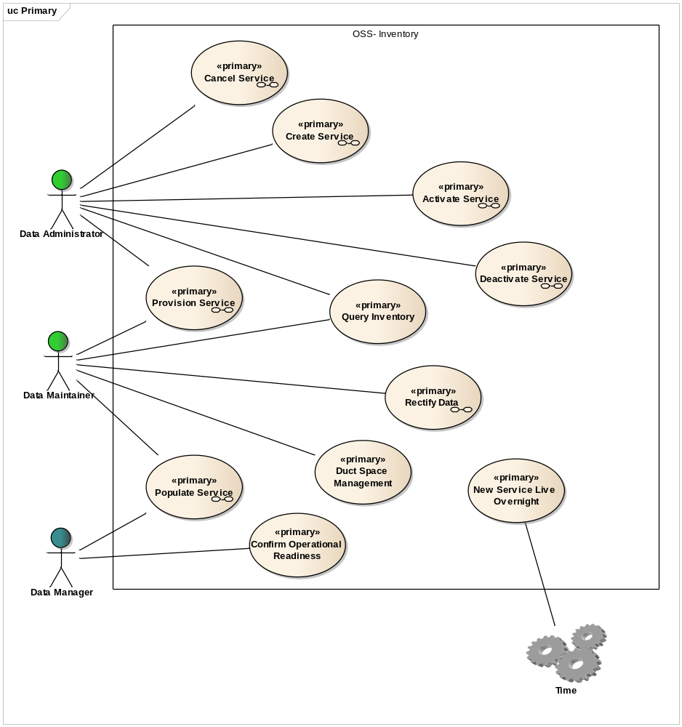
Figure 27 - Inventory Management Use Case diagram

Create Service
The figure below is an Activity diagram for this Use Case and details the ‘activities’ required to complete this task. This Activity diagram summarises the full Use Case.
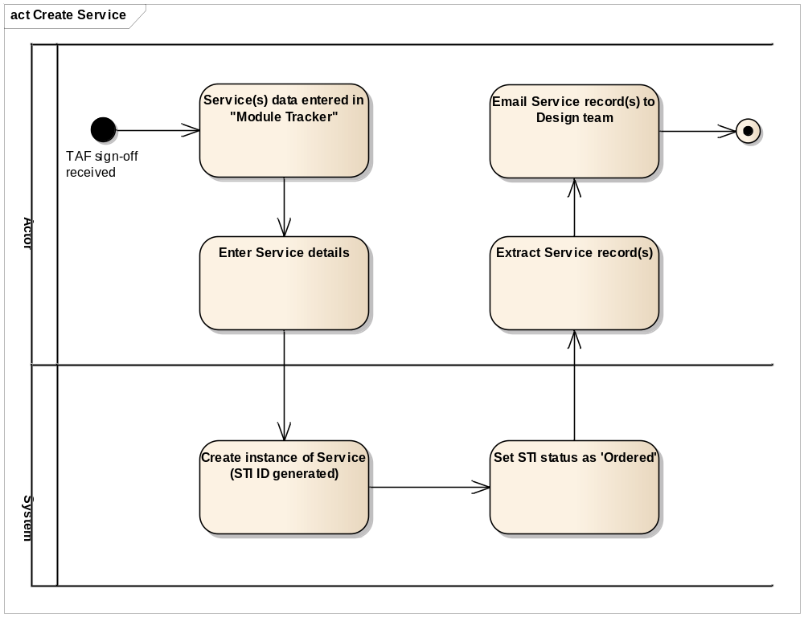
Figure 28 - Create Service Activity diagram
There is no change to the Create Service Use Case as referenced in [9] in Section 1.4. This Use Case will be instantiated for MM Lite. The information below will be used for that instantiation.

Supplementary Information
The following details the supplementary information required to provide the specific details related to Managed Motorways Lite:
Basic Flow - Create Service Shell from TAF, Step 3, Sub-step a.
- FR583: The existing functionality of the Service Schedule within the Inventory Management system (which allows creation, modification and deletion of Service Type Instances) shall be extended to the following new Service Types:
  - ST8RH
  - ST8RDH
  - ST8RC2
  - ST8RCO1
  - ST8RCO2
  - ST8RCO2D
  - ST10C2
  - ST10C2D
  - ST10CO1
  - ST10CO2
  - ST10CO2D

Populate Service
The figure below is an Activity diagram for this Use Case and details the ‘activities’ required to complete this task. This Activity diagram summarises the full Use Case.
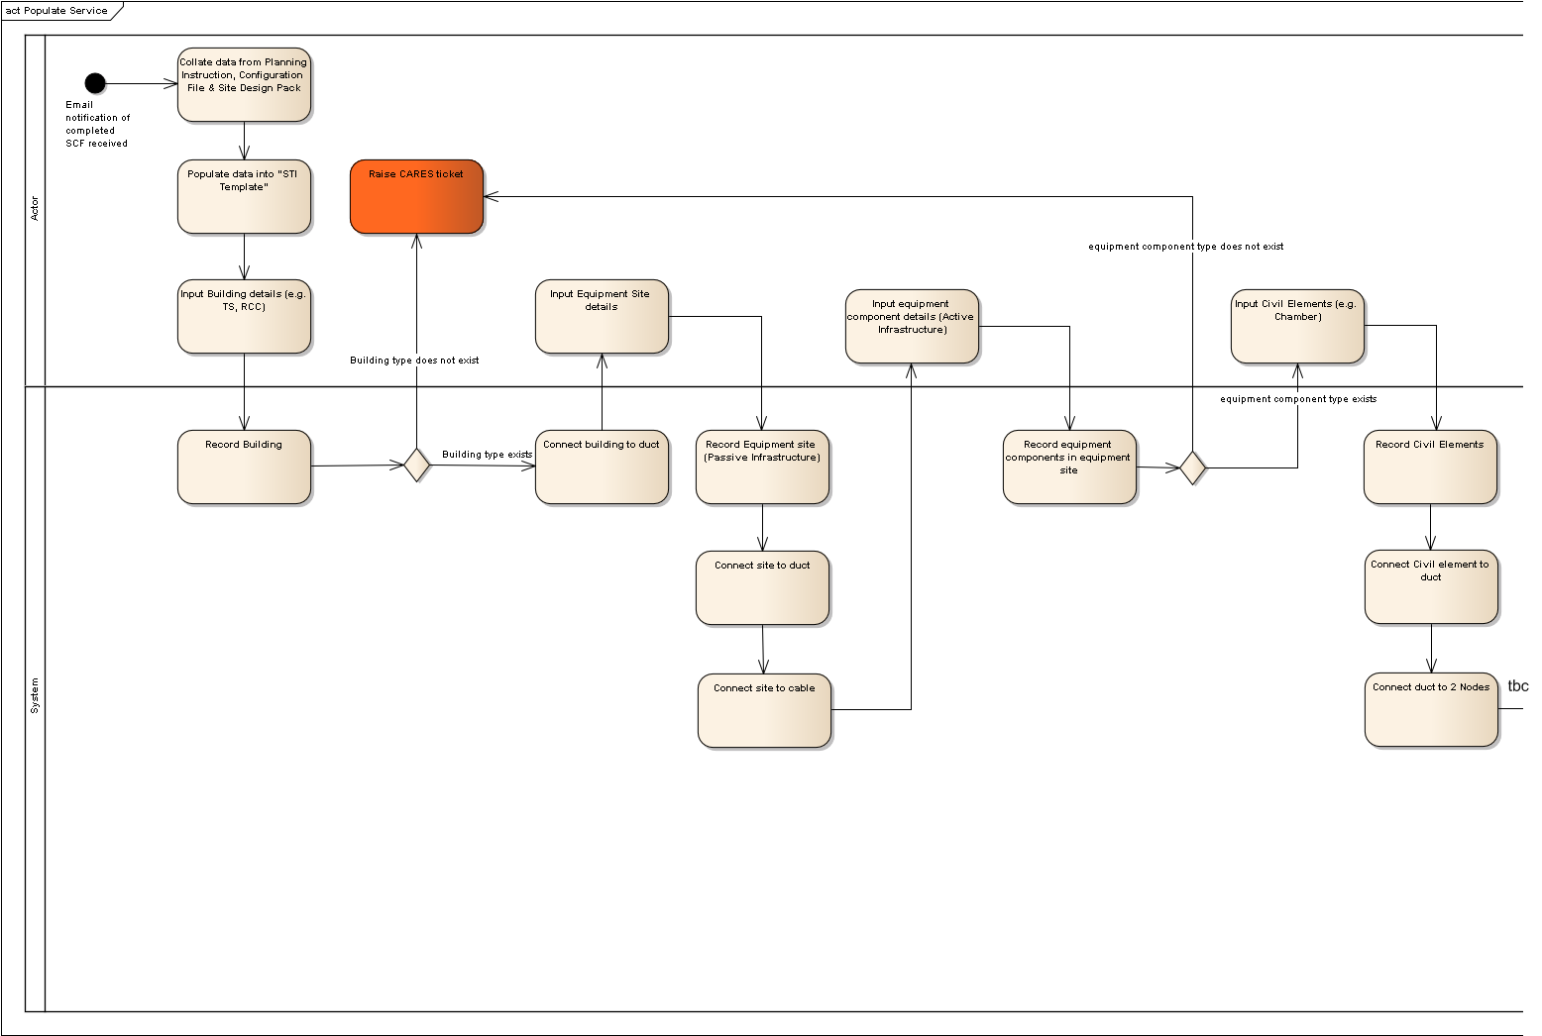
Figure 29: Populate Service Activity diagram (Pt1 of 2)
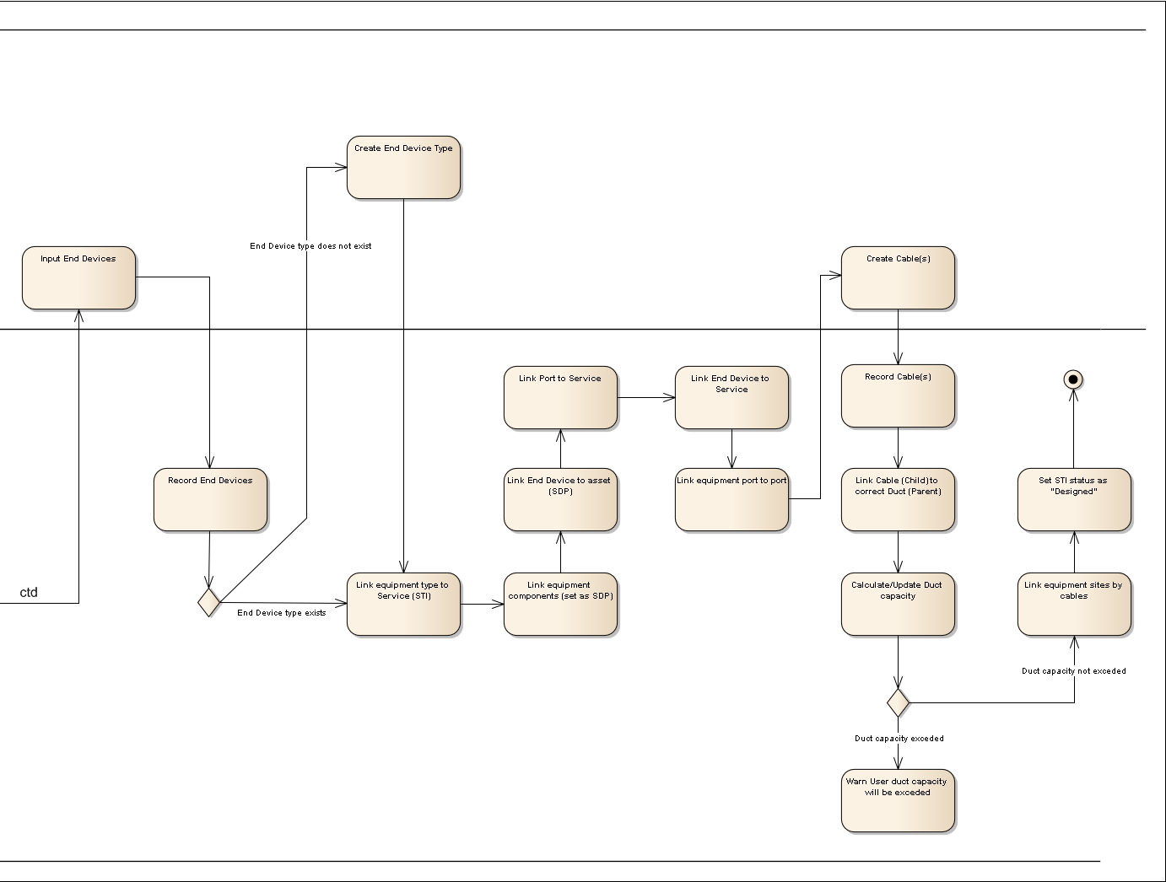
Figure 30 - Populate Service Activity diagram (Pt 2 of 2)
There is no impact to the Populate Service Use Case as referenced in [10] in Section 1.4. This Use Case will be instantiated for MM Lite. The information below will be used for that instantiation.

Supplementary Information
The following details the supplementary information required to provide the specific details related to Managed Motorways Lite:
Basic Flow – Populate Service, Step 2.
- FR588: The system shall support representation of the Infrastructure Scenarios within the Service Templates.
Basic Flow – Populate Service, Step 7, Sub-step a and b.
- FR582: New catalogue items and templates shall be created within the Inventory Management system for the 7210SAS-M.
There is an AC variant and a DC variant.
AC variant:
o 1GE_SFP port (occurs 24 times)
o 10GE_XFP port (occurs 2 times)
o PSU Port
o Console Port
o Management Port
o FAN
o AC PSU
The DC variant is identical to the AC variant described above, apart from the fact that the last item will be a DC PSU rather than an AC PSU
Both the AC variant and the DC variant may optionally have an MDA with two 10GE_XFP ports.
- FR662: New catalogue items and templates shall be created within the Inventory Management system for the 7210SAS-D.
Unlike the SAS_M, the SAS_D will always have the same attributes, as there are no variants or optional extras.
o 1GE_SFP port (occurs 6 times)
o 1GE_BTX port (occurs 4 times)
o Console_Port
o PSU_Port
- FR663: A new template needs to be created for the Copper-based Telindus Solo MPEG-2 encoder with two ports. Catalogue items and templates already exist in the Inventory Management system for the Copper-based Telindus Solo MPEG-2 encoder with one port.
Basic Flow – Populate Service, Step 13.
- FR587: The existing functionality of the inventory system which allows each Service Type Instance to include the links between the ports in each corresponding device shall be extended to the Service Types listed below:

Basic Flow – Populate Service, Step 18, Sub-step b.

Provision Service
The figure below is an Activity diagram for this Use Case and details the ‘activities’ required to complete this task. This Activity diagram summarises the full Use Case.
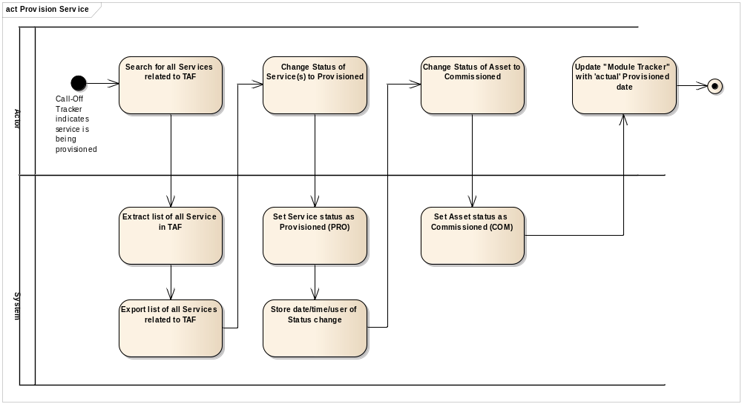
Figure 31 - Provision Service Activity diagram
There is no impact to the Provision Service Use Case as referenced in [11] in Section 1.4. This Use Case will be instantiated for MM Lite. The information below will be used for that instantiation.

Supplementary Information
The following details the supplementary information required to provide the specific details related to Managed Motorways Lite:
Basic Flow – Provision Service, Step 3, Sub-step a.
FR583: The existing functionality of the Service Schedule within the Inventory Management system (which allows creation, modification and deletion of Service Type Instances) shall be extended to the following new Service Types:
- ST8RH
- ST8RDH
- ST8RC2
- ST8RCO1
- ST8RCO2
- ST8RCO2D
- ST10C2
- ST10C2D
- ST10CO1
- ST10CO2
- ST10CO2D

Activate Service
The figure below is an Activity diagram for this Use Case and details the ‘activities’ required to complete this task. This Activity diagram summarises the full Use Case.
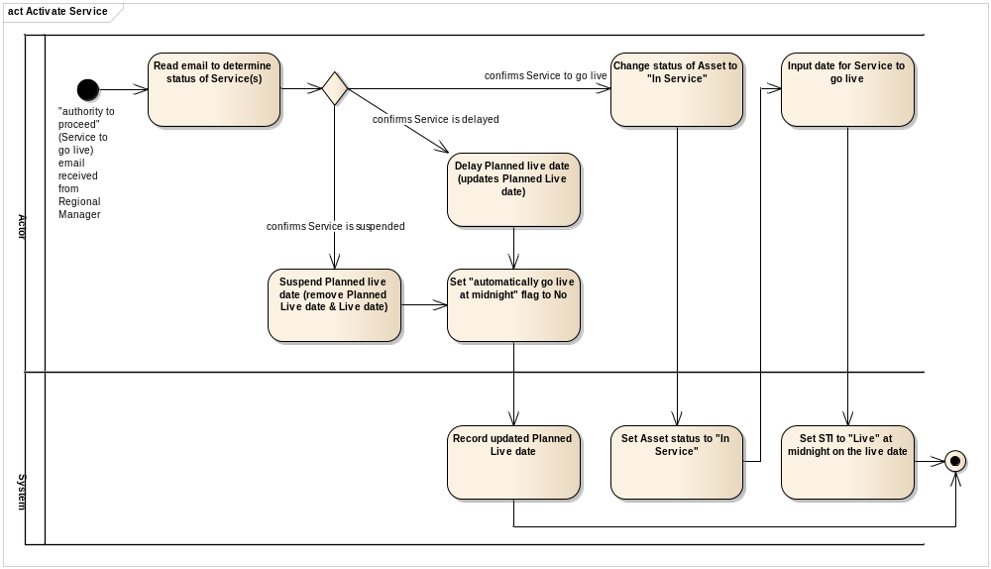
Figure 32 - Activate Service Activity diagram
There is no impact to the Activate Service Use Case as referenced in [12] in section 1.4. This Use Case will be instantiated for MM Lite. The information below will be used for that instantiation.

Supplementary Information
The following details the supplementary information required to provide the specific details related to Managed Motorways Lite:
Basic Flow – Activate Service, Step 3, Sub-step a.
- FR583: The existing functionality of the Service Schedule within the Inventory Management system (which allows creation, modification and deletion of Service Type Instances) shall be extended to the following new Service Types:

Deactivate Service
The figure below is an Activity diagram for this Use Case and details the ‘activities’ required to complete this task. This Activity diagram summarises the full Use Case.
- ST8RH
- ST8RDH
- ST8RC2
- ST8RCO1
- ST8RCO2
- ST8RCO2D
- ST10C2
- ST10C2D
- ST10CO1
- ST10CO2
- ST10CO2D
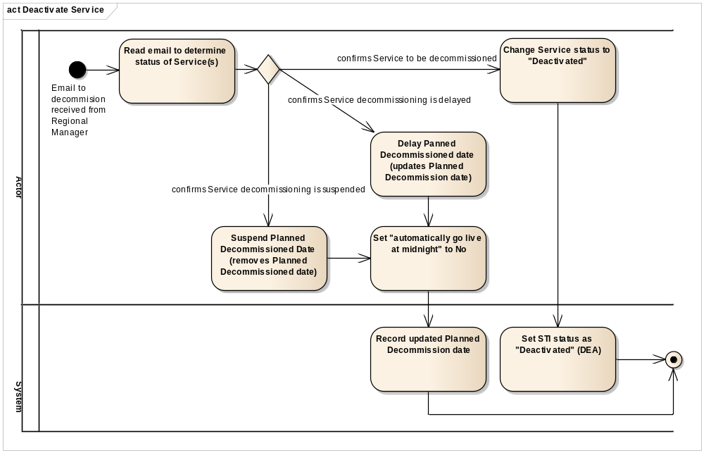
Figure 33 - Decommission Service Activity diagram
There is no impact to the Deactivate Service Use Case as referenced in [13] in Section 1.4. This Use Case will be instantiated for MM Lite. The information below will be used for that instantiation.

Supplementary Information
The following details the supplementary information required to provide the specific details related to Managed Motorways Lite:
Basic Flow – Deactivate Service, Step 3, Sub-step a.
- FR583: The existing functionality of the Service Schedule within the Inventory Management system (which allows creation, modification and deletion of Service Type Instances) shall be extended to the following new Service Types:
  - ST8RH
  - ST8RDH
  - ST8RC2
  - ST8RCO1
  - ST8RCO2
  - ST8RCO2D
  - ST10C2
  - ST10C2D
  - ST10CO1
  - ST10CO2
  - ST10CO2D

Rectify Data
The figure below is an Activity diagram for this Use Case and details the ‘activities’ required to complete this task. This Activity diagram summarises the full Use Case.
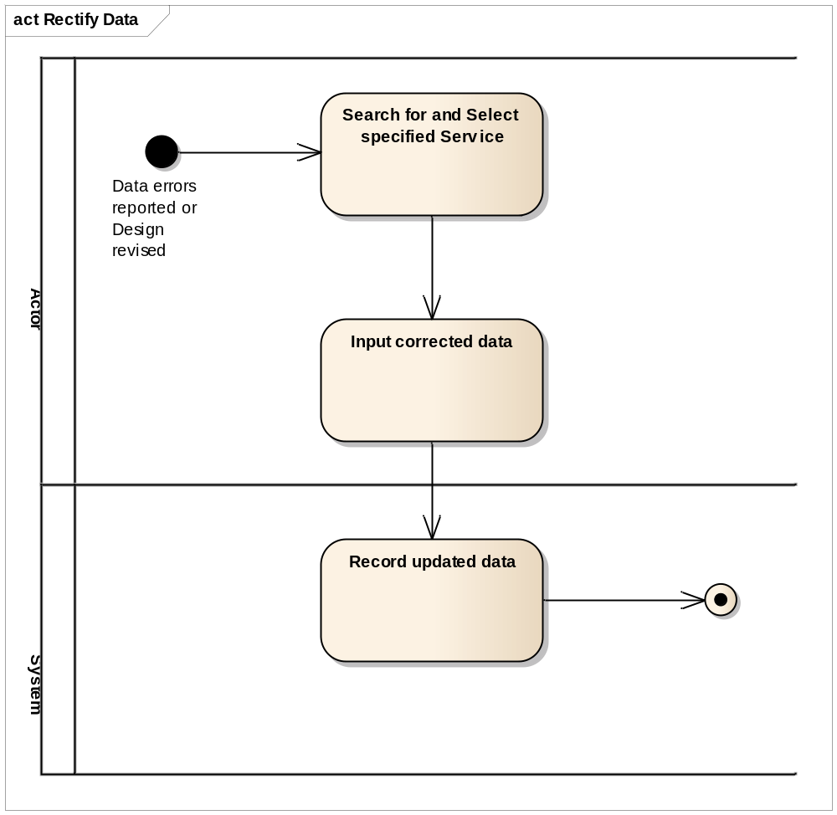
Figure 34 - Rectify Data Activity diagram
There is no impact to the Rectify Data Use Case as referenced in [14] in Section 1.4. This Use Case will be instantiated for MM Lite. The information below will be used for that instantiation.

Supplementary Information
The following details the supplementary information required to provide the specific details related to Managed Motorways Lite:
Basic Flow – Rectify Data, Step 2.
- FR582: New catalogue items and templates shall be created within the Inventory Management system for the 7210SAS-M.
There is an AC variant and a DC variant.
AC variant:
o 1GE_SFP port (occurs 24 times)
o 10GE_XFP port (occurs 2 times)
o PSU Port
o Console Port
o Management Port
o FAN
o AC PSU
The DC variant is identical to the AC variant described above, apart from the fact that the last item will be a DC PSU rather than an AC PSU
Both the AC variant and the DC variant may optionally have an MDA with two 10GE_XFP ports.
- FR662: New catalogue items and templates shall be created within the Inventory Management system for the 7210SAS-D.
Unlike the SAS_M, the SAS_D will always have the same attributes, as there are no variants or optional extras.
o 1GE_SFP port (occurs 6 times)
o 1GE_BTX port (occurs 4 times)
o Console_Port
o PSU_Port
- FR663: A new template needs to be created for the Copper-based Telindus Solo MPEG-2 Encoder with two ports. Catalogue items and a template already exist in the Inventory Management system for the Copper-based Telindus Solo MPEG-2 encoder with one port.
- FR587: The existing functionality of the inventory system which allows each Service Type Instance to include the links between the ports in each corresponding device shall be extended to the Service Types listed below:
  - ST8RH
  - ST8RDH
  - ST8RC2
  - ST8RCO1
  - ST8RCO2
  - ST8RCO2D
  - ST10C2
  - ST10C2D
  - ST10CO1
  - ST10CO2
  - ST10CO2D

- FR589.1: The existing functionality of the inventory system which displays the geographic location of each asset on the GIS maps shall be extended to represent the new equipment types, i.e.:
o 7210SAS-M
o 7210SAS-D
o Telindus Solo MPEG-2 Encoder - 1 port optical based Solo
o Telindus Solo MPEG-2 Encoder - 2 port optical based Solo
o Telindus Solo MPEG-2 Encoder - 2 port copper based Solo
- FR590: Each Active Telecom asset shall have a unique identifier within the Inventory Management system. Note that location may be a component of the Identifier, but it shall always be just a component of the identifier.

Cancel Service
The figure below is an Activity diagram for this Use Case and details the ‘activities’ required to complete this task. This Activity diagram summarises the full Use Case.
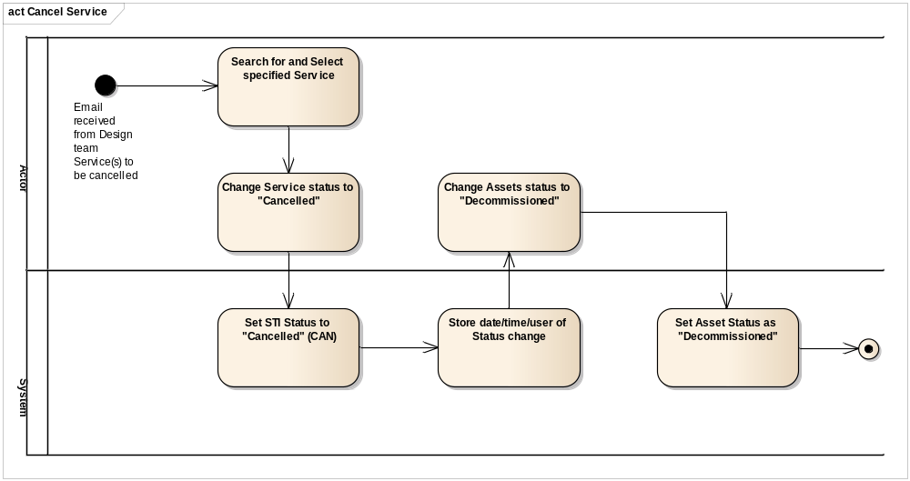
Figure 35 - Cancel Service Activity diagram
There is no impact to the Cancel Service Use Case as referenced in [15] in Section 1.4. This Use Case will be instantiated for MM Lite. The information below will be used for that instantiation.

Supplementary Information
The following details the supplementary information required to provide the specific details related to Managed Motorways Lite:
Basic Flow – Cancel Service, Step 2, Sub-step a.
FR583: The existing functionality of the Service Schedule within the Inventory Management system (which allows creation, modification and deletion of Service Type Instances) shall be extended to the following new Service Types:
- ST8RH
- ST8RDH
- ST8RC2
- ST8RCO1
- ST8RCO2
- ST8RCO2D
- ST10C2
- ST10C2D
- ST10CO1
- ST10CO2
- ST10CO2D

Basic Flow – Cancel Service, Step 3, Sub-step a.
- FR582: New catalogue items and templates shall be created within the Inventory Management system for the 7210-SAS-M.
There is an AC variant and a DC variant.
AC variant:
o 1GE_SFP port (occurs 24 times)
o 10GE_XFP port (occurs 2 times)
o PSU Port
o Console Port
o Management Port
o FAN
o AC PSU
The DC variant is identical to the AC variant described above, apart from the fact that the last item will be a DC PSU rather than an AC PSU
Both the AC variant and the DC variant may optionally have an MDA with two 10GE_XFP ports.
- FR662: New catalogue items and templates shall be created within the Inventory Management system for the 7210SAS-D.
Unlike the SAS_M, the SAS_D will always have the same attributes, as there are no variants or optional extras.
o 1GE_SFP port (occurs 6 times)
o 1GE_BTX port (occurs 4 times)
o Console_Port
o PSU_Port
- FR663: A new template needs to be created for the Copper-based Telindus Solo MPEG-2 encoder with two ports. Catalogue items and a template already exist in the Inventory Management system for the Copper-based Telindus Solo MPEG-2 encoder with one port.

Fault Management
The figure below shows the Use Case diagram for the whole of Fault Management. The Use Case diagram describes the set of actions, objectives, or goals, to be realised within the OSS Solution with each individual Use Case describing a user’s interaction with a process via IT tasks. The sections below this figure provide the specific details of the Use Case changes to be made for MM Lite.
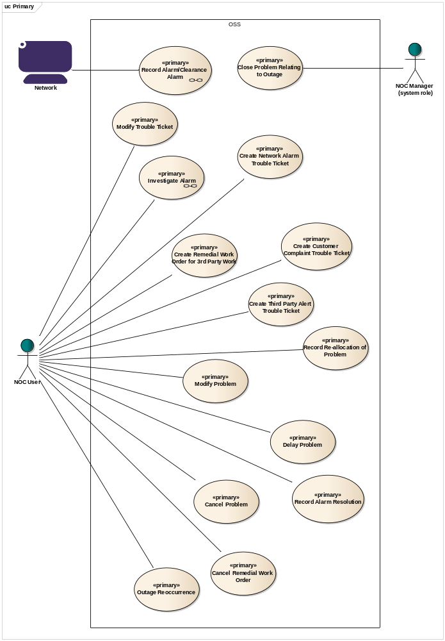
Figure 36 - Fault Management Use Case diagram

Record Alarm-Clearance Alarm
The figure below is an Activity diagram for this Use Case and details the ‘activities’ required to complete this task. This Activity diagram summarises the full Use Case.
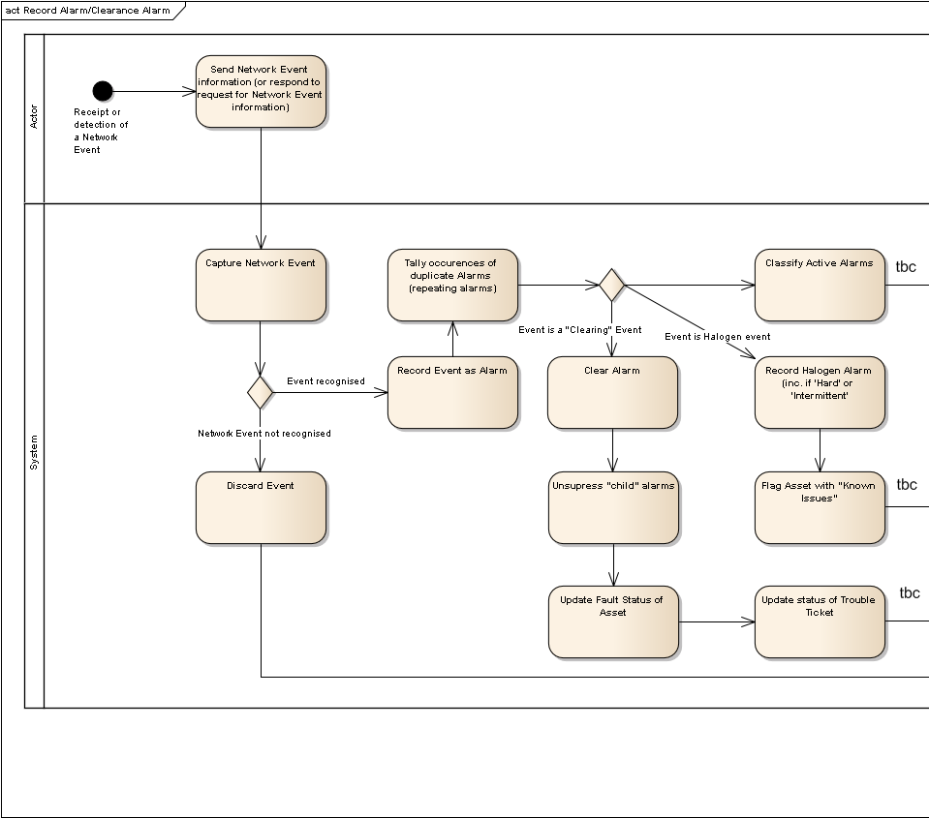
Figure 37: Record Alarm-Clearance Alarm Activity diagram (Pt 1 of 2)
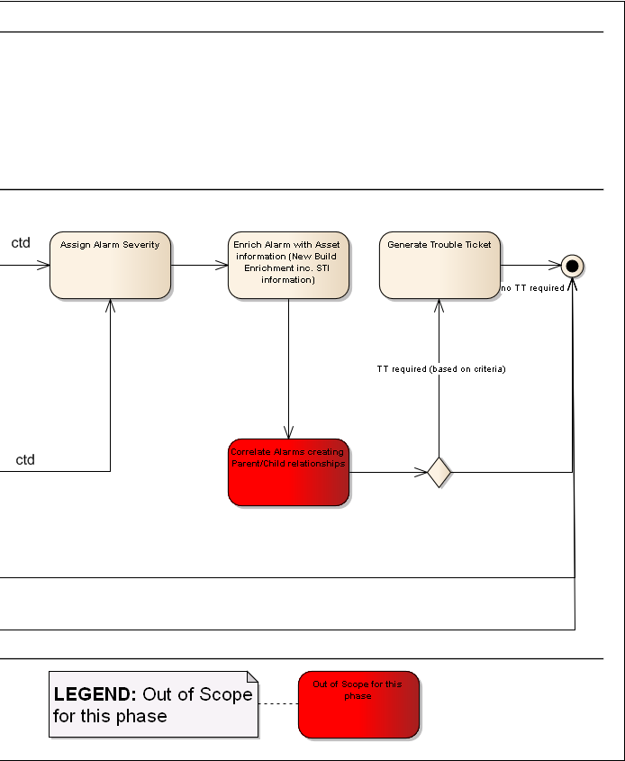
Figure 38 - Record Alarm-Clearance Alarm Activity diagram (Pt 2 of 2)
There is no impact to the Record Alarm-Clearance Alarm Use Case as referenced in [17] in Section 1.4. This Use Case will be instantiated for MM Lite. The information below will be used for that instantiation.

Supplementary Information
The following details the supplementary information required to provide the specific details related to Managed Motorways Lite:
Basic Flow – Raised Alarm, Step 1.
- FR628: Where an alarm that is not defined by the Alarm List is received by the Fault Management system, it shall store the alarm, without enrichment or correlation, as per the existing functionality.
Basic Flow – Raised Alarm, Step 2.
- FR595: The Netcool MTTRAPD probe shall receive alarms from the Cellstack relating to the Telindus Solo MPEG-2 Encoder. These alarms shall be defined within an agreed Alarm List.
- FR596: The Netcool 5620 SAM probe shall receive events relating to the 7210SAS-Ms from the 5620 Sam. The alarms shall be defined within an agreed Alarm List.
- FR596.1: The Netcool 5620 SAM probe shall receive events relating to the 7210SAS-Ds from the 5620 Sam. The alarms shall be defined within an agreed Alarm List.
Basic Flow – Raised Alarm, Step 8.
- FR601: The existing "new build" enrichment process shall be applied to the alarms coming from the Telindus Solo MPEG-2 Encoders.
- FR601.1: The existing "new build" enrichment process shall be applied to the alarms coming from the 7210SAS-Ms.
- FR601.2: The existing "new build" enrichment process shall be applied to the alarms coming from the 7210SAS-Ds.
- FR614: The existing "new build" enrichment policy, which includes populating the alarm with impacted STIs and associated STI IDs, will be extended for Service affecting alarms coming from MM Lite devices (e.g. 7210SAS-M, 7210SAS-D, Telindus SOLO Encoder).
- FR671: The solution shall identify services critical to the business services e.g. loss of comms to Hard Shoulder Monitoring (HSM) camera(s) by enriching the alarm to identify the STI affected is Hard Shoulder impacting.
Alternative Flow – Network Alarm Trouble Ticket Generation, Step 2.
- FR618: For service affecting alarms, the fault management system shall raise a trouble ticket and notify the trouble-ticketing system with the relevant information.

Exceptions
- Section 1.1: No Parent/Child Relationships
- Section 1.6/Step 4: No Parent/Child Relationships
- Section 2.1/Step 9: No Parent/Child Relationships

Investigate Alarm
The figure below is an Activity diagram for this Use Case and details the ‘activities’ required to complete this task. This Activity diagram summarises the full Use Case.
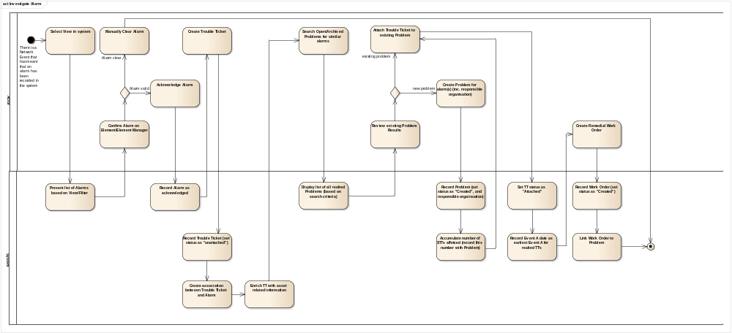
Figure 39 - Investigate Alarm Activity diagram
There is no impact to the Cancel Service Use Case as referenced in [18] in Section 1.4. This Use Case will be instantiated for MM Lite. The information below will be used for that instantiation.

Supplementary Information
The following details the supplementary information required to provide the specific details related to Managed Motorways Lite:
Basic Flow – Investigate Alarm and create Remedial Work Order, Step 1, Sub-step a.
- FR604: Filters shall be defined so that only relevant alarms are displayed to NOC operators.
- FR629: Where an alarm that is not defined by the Alarm List is received by the Fault Management system, the alarm shall not be displayed in the views normally used by the operators, but shall be available in separate views.
- FR631: The users shall be able to amend existing views and create additional views.
- FR632: A view that only displays MM Lite alarms shall be created within the Fault Management system.
- FR633: A view that only displays MM Lite Service Affecting alarms shall be created within the Fault Management system.
- FR672: The solution shall provide a Netcool view showing events affecting critical services e.g. loss of comms to Hard Shoulder Monitoring (HSM) camera(s).

Business Processes
In section 3.2.2.2, points 5 and 6 make reference to two fields in Circee pertinent to MMLite. These require changes to the Highways Agency and Quinton Data Team business processes.
Field SYSTEM_TYPE in the END_DEVICE table - this field is currently populated in the GUI via a drop-down list. A new value (HSM) has been added to this drop down list. When creating a camera in Circee where the camera is to be used on the hard shoulder of a motorway, the Quinton Data Team must populate the SYSTEM_TYPE field with value “HSM”.
Field STI_HA_IMPACT in the STI table - this field currently defaults to 1. All STIs in the system currently have the default value. The Highways Agency will define rules for setting this field in order to reflect priorities for STIs. Currently, a need has been identified to categorise STIs that involve hard shoulder cameras, according to the type of road they are used to monitor. As and when new requirements for such categorizations are identified, the Highways Agency will amend the rules for populating this field accordingly. Once the rules have been defined, the Quinton Data team will follow them when performing data population.
Alarms affecting cameras used to monitor hard shoulders of motorways (i.e. where the field holding the END_DEVICE value is set to HSM) will appear in a special view in Netcool. The operators will use manual procedures to alert the Highways Agency of such occurrences.

Data Flow
There are no changes to inter system data flows.

Interfaces

External Interface Changes
Not applicable.

Internal Interface Changes
Not applicable.
Section 4: Non Functional Architecture

Non-Functional Architecture
This section describes the changes to the non-functional capability of the system to support Work Package 199 and the new MMLite devices. Against each non-functional capability, it describes the hardware, software, network (data communications and management) and security elements impacted and the changes to be made to each.

Capacity and Dimensioning
A full and specific planning model cannot be produced at this stage. A performance monitoring and capacity modelling exercise needs to take place beforehand and this in turn needs to be performed on the upgraded Netcool deployment. A MMLite specific capacity model will be provided in the MMLite full solution phase (phase 3).
Documentation specifying the aforementioned performance monitoring and capacity modelling exercises will be provided as separate deliverables.
For now, this section discusses the aspects of capacity and dimensioning that need to be considered.
To ensure that the existing platform will be able to cater for the volume and rate of alarms that will be generated by the MMLite devices, a capacity and dimension modelling exercise will be carried out. The specific aims of the exercise are as follows.
To identify the current performance of the platforms with specific focus on
- CPU Utilisation
- Memory utilisation
To identify the current performance of the applications with a specific focus on
- Probe rules processing overhead
- Event rates
- The load on the ObjectServer (automations, client access etc).
The following IBM guidelines for sizing of hosting platforms are by the size of the managed network and the architecture employed, the HA Netcool deployment would fall into the category of a small or standard deployment due to its single tiered nature and relatively small number of resident events (<50000).

Component | IBM Recommendation | Current Setup | Description
Standard ObjectServer | Cores:2  Physical Memory: 4GB | Cores:4  Physical Memory: 12GB | The ObjectServer is currently co-located with Impact. The ObjectServer being a 32 bit application can only ever use up to 4Gb of memory. In normal conditions, a standard Object Server will use 1-2 CPUS. It is not anticipated that any changes will be required to support the Managed Motorways Lite deployment
Probes | Cores:2  Physical Memory: 2GB  (Per Probe) | Cores: 2  Physical Memory: 8GB | Currently, there are 5 probes located in the same container. The current setup already crosses the limit of the IBM recommendations in terms of CPU cores.  In terms of memory usage, the probe will require some memory for storing the rules files on startup and for storing the traps in the queue. Each trap takes up 1500 + 128 bytes of memory. 0.5Mb should be allowed for particularly large rules files. This would mean the probe would require approximately 100Mb of memory. (calculated by (60000 * (1500 + 128))/1048576 + 0.5 Mb).
Table 5 - Server Sizing Guidelines

Migration
No change.

Availability
No change.

Back up and Restore
No change.

Data Storage
No change.

Security
No change

Reliability
No change.
SECTION 5: Impacted Functional Specification Documents

Impacted Functional Specification Documents
The documents listed in the table below will be updated to bring them in line with design changes as described in this high level document.
Sub System | Sub System | LLD / DSD Document Name
Fault Management | Netcool | GYSRGDSSP0007_R08 PS-DS036-07 FUNCTIONAL SPECIFICATION NETCOOL.doc
Inventory Management | Circee | GYSRGDSSP0009_R21 PS-DS036-05 Functional Specification Circee.doc
Table 6 - List of Impacted Functional Specification Documents
Changes to the other sub-systems and their consented documents will be identified and performed during the Full Solution Phase (Phase 3).
SECTION 6: Requirements and Solution Traceability

Requirements and Solution Traceability
This section details all the Functional Requirements gathered for delivery of the IAMS phase of MM Lite. All requirements, regardless of status, have been included to provide an overall picture of what is being delivered in this phase, what is being delivered in a future phase and what is not being delivered. The status of the requirements is defined below:
- Incorporated: The requirement is supported by the existing functionality within the associated sub-system.
- Deferred: The requirement is to be revised and delivered in a later phase.
- Proposed: The requirement is valid but yet to be agreed with the customer.
- Agreed: The requirement is valid and agreed with the customer.
- For Review: The requirement needs to be verified or requires additional information.
- Duplicate: The requirement is considered as a copy (duplicate) of another valid requirement. The duplicated requirement will be detailed in the Compliance Statement column.
- N/A: The requirement is not applicable for the Work Package and/or not a valid requirement. These remain within the list in order to ensure continuity of requirement numbering.
- Obsolete: The requirement is no longer required.

Functional Requirements and Requirements Mapping
FR Tag | Requirement text | Status | Sub-Category | Candidate Use Cases | Phase | DocSection | Compliance Status | Compliance Statement | Traced-to
FR581 | The solution shall allow a QDT User to create, read, update and delete all the new Passive Telecom Infrastructure (e.g. Cables, Fibres) required to manage the new network equipment. | Incorporated | Circee | Manage Inventory Item | 190/199 Ph 1c - Circee Assets | N/A | Full | No FR required as existing functionality as detailed within Circee Functional Spec | BR495
FR582 | New catalogue items and templates shall be created within the Inventory Management system for the 7210_SAS_M.  There is an AC variant and a DC variant.  AC variant:  o 1GE_SFP port (occurs 24 times)  o 10GE_XFP port (occurs 2 times)  o PSU Port  o Console Port  o Management Port  o FAN  o AC PSU  The DC variant is identical to the AC variant described above, apart from the fact that the last item will be a DC PSU rather than an AC PSU  Both the AC variant and the DC variant may optionally have an MDA with two 10GE_XFP ports. | Proposed | Circee | Manage Inventory Item | 190/199 Ph 1c - Circee Assets | 3.2.2.2 | Full |  | BR496
FR583 | The existing functionality of the Service Schedule within the Inventory Management system (which allows creation, modification and deletion of Service Type Instances) shall be extended to the following new Service Types:  ST8RH  ST8RDH  ST8RC2  ST8RCO1  ST8RCO2  ST8RCO2D  ST10C2  ST10C2D  ST10CO1  ST10CO2  ST10CO2D | Proposed | Circee | Manage Inventory Item | 190/199 Ph 1c - Circee Assets | 3.2.2.2 | Full |  | BR497, BR503
FR587 | The existing functionality of the inventory system which allows each Service Type Instance to include the links between the ports in each corresponding device shall be extended to the Service Types listed below:  ST8RH  ST8RDH  ST8RC2  ST8RCO1  ST8RCO2  ST8RCO2D  ST10C2  ST10C2D  ST10CO1  ST10CO2  ST10CO2D | Proposed | Circee | Manage Inventory Item | 190/199 Ph 1c - Circee Assets | 3.2.2.2 | Full |  | BR500
FR588 | The system shall support representation of the Infrastructure Scenarios within the Service Templates. | Proposed | Circee | Manage Inventory Item | 190/199 Ph 2 - IAMS | 3.2.2.2 | Full |  | BR501
FR589.1 | The existing functionality of the inventory system which holds the GIS for each asset shall be extended to include the new equipment types, i.e.:  o 7210 SAS-M  o 7210 SAS-D  o Telindus Solo MPEG-2 Encoder - 1 port optical based Solo  o Telindus Solo MPEG-2 Encoder - 2 port optical based Solo  o Telindus Solo MPEG-2 Encoder - 2 port copper based Solo | Proposed | Circee | Manage Inventory Item | 190/199 Ph 1c - Circee Assets |  |  |  | BR502
FR590 | Each Active Telecom asset shall have a unique identifier within the Inventory Management system. Note that location may be a component of the Identifier, but it shall always be just a component of the identifier. | Proposed | Circee | Manage Inventory Item | 190/199 Ph 1c - Circee Assets |  | Full |  | BR504
FR662 | New catalogue items and templates shall be created within the Inventory Management system for the 7210 SAS_D.  Unlike the SAS_M, the SAS_D will always have the same attributes, as there are no variants or optional extras.  o 1GE_SFP port (occurs 6 times)  o 1GE_BTX port (occurs 4 times)  o Console_Port  o PSU_Port | Proposed | Circee | Manage Inventory Item | 190/199 Ph 1c - Circee Assets | 3.2.2.2 | Full |  | BR496
FR663 | A new template needs to be created for the Copper-based Telindus Solo MPEG-2 encoder with two ports. Catalogue items and a template already exist in the Inventory Management system for the Copper-based Telindus Solo MPEG-2 encoder with one port. | Proposed | Circee | Manage Inventory Item | 190/199 Ph 1c - Circee Assets | 3.2.2.2 | Full |  | BR498
FR664 | A new catalogue item (Optical fast port) and templates shall be created within the Inventory Management system for the fibre-based Telindus Solo MPEG-2 Encoder. There are two variants.  Single port variant:  o LAN port (occurs twice)  o Optical Fast Ethernet port  o Video in port  o Console data port (occurs twice)  The two port variant will have an extra Optical fast Ethernet port | Proposed | Circee | Manage Inventory Item | 190/199 Ph 1c - Circee Assets | 3.2.2.2 | Full |  | BR498
FR673 | The solution shall allow the user to record assets related to critical services (e.g. Hard Shoulder Monitoring (HSM) camera) via the GUI. | Proposed | Circee | Manage Inventory Item | 190/199 Ph 1c - Circee Assets | 3.2.2.2 | Full |  | BR580
FR586 | The network topology data required for the management of the new Network shall be fully populated with the agreed Infrastructure Scenario data. | N/A | Circee | Manage Inventory Item |  |  | N/A | Data population will be actioned by Genesys. Business Requirement still valid. | BR499
FR584 | For the 7210 SAS-M, a user shall be able to record the following port types:  SFP (24 ports)  XFP (2 ports) | Duplicate | Circee | Manage Inventory Item | 190/199 Ph 1c - Circee Assets |  |  | Duplicate of FR582 (ports now included in requirement text) | BR498
FR585 | For the 7210 SAS-D, a user shall be able to record the following port types: SFP (6 ports), RJ45 (4 ports),For the 7210 SAS-D, a user shall be able to record the following port types:  SFP (6 ports)  RJ45 (4 ports) | Duplicate | Circee | Manage Inventory Item | 190/199 Ph 1c - Circee Assets | 3.2.2.2 | Full | Duplicate of FR582 (ports now included in requirement text) | BR498
FR607 | As per the defined deduplication rules in the Alarm List, multiple occurrences of the same event shall appear in the Fault Management system as a single Alarm. | Agreed | Netcool | De-duplicate Event | 190/199 Ph 2 - IAMS, 190/199 Ph 3 - Full Solution | 3.2.1.1 | Full |  | BR509
FR603 | Views shall be defined to ensure the Alarm List attributes are displayed to NOC operators. | Agreed | Netcool | Define Alarm View | 190/199 Ph 2 - IAMS, 190/199 Ph 3 - Full Solution | 3.2.1.3 | Full |  | BR507
FR604 | Filters shall be defined so that only relevant alarms are displayed to NOC operators. | Agreed | Netcool | Define Alarm View | 190/199 Ph 2 - IAMS, 190/199 Ph 3 - Full Solution | 3.2.1.3 | Full |  | BR507
FR672 | The solution shall provide a Netcool view showing events affecting critical services e.g. loss of comms to Hard Shoulder Monitoring (HSM) camera(s). | Agreed | Netcool | Define View | 190/199 Ph 2 - IAMS, 190/199 Ph 3 - Full Solution | 3.2.1.3 | Full |  | BR580
FR602 | All attributes defined in the Alarm List shall be available for display within the Fault Management system. | Agreed | Netcool | Display Alarm | 190/199 Ph 2 - IAMS, 190/199 Ph 3 - Full Solution | 3.2.1.3 | Full |  | BR507
FR634 | The Fault Management system shall allow the user to apply custom filters to any views. | Agreed | Netcool | Display Alarm | 190/199 Ph 2 - IAMS, 190/199 Ph 3 - Full Solution | 3.2.1.3 | Full |  | BR519
FR631 | The users shall be able to amend existing views and create additional views. | Agreed | Netcool | Display Alarm, Define Alarm View | 190/199 Ph 2 - IAMS, 190/199 Ph 3 - Full Solution | 3.2.1.3 | Full |  | BR518
FR632 | A view that only displays SPCE infrastructure alarms shall be created within the Fault Management system. | Agreed | Netcool | Display Alarm, Define Alarm View | 190/199 Ph 2 - IAMS, 190/199 Ph 3 - Full Solution | 3.2.1.3 | Full |  | BR510, BR518
FR633 | A view that only displays SPCE outages shall be created within the Fault Management system. | Agreed | Netcool | Display Alarm, Define Alarm View | 190/199 Ph 2 - IAMS, 190/199 Ph 3 - Full Solution | 3.2.1.3 | Full |  | BR518
FR601 | The existing "new build" enrichment process shall be applied to the alarms coming from the Telindus Solo MPEG-2 Encoders. | Agreed | Netcool | Enrich Alarm | 190/199 Ph 2 - IAMS | 3.2.1.1 | Full |  | BR506
FR601.1 | The existing "new build" enrichment process shall be applied to the alarms coming from the 7210 SAS-Ms. | Agreed | Netcool | Enrich Alarm | 190/199 Ph 2 - IAMS, 190/199 Ph 3 - Full Solution | 3.2.1.1 | Full |  | BR506
FR601.2 | The existing "new build" enrichment process shall be applied to the alarms coming from the 7210 SAS-Ds. | Agreed | Netcool | Enrich Alarm | 190/199 Ph 2 - IAMS, 190/199 Ph 3 - Full Solution | 3.2.1.1 | Full |  | BR506
FR601.3 | Each alarm shall be enriched with the Geographic location of the asset it to which it relates. | Agreed | Netcool | Enrich Alarm | 190/199 Ph 2 - IAMS, 190/199 Ph 3 - Full Solution | 3.2.1.1 | Full |  | BR506
FR608 | The solution shall mark an Alarm as requiring NOC action based on information in the Alarm List. | Agreed | Netcool | Enrich Alarm | 190/199 Ph 2 - IAMS, 190/199 Ph 3 - Full Solution | 3.2.1.1 | Full |  | BR510
FR610 | For alarms requiring NOC action, the system shall mark an alarm as resilience affecting, based on information in the Alarm List. | Agreed | Netcool | Enrich Alarm | 190/199 Ph 2 - IAMS, 190/199 Ph 3 - Full Solution | 3.2.1.1 | Full |  | BR511
FR611 | For alarms requiring NOC action, the system shall mark an alarm as service affecting, based on information in the Alarm List. | Agreed | Netcool | Enrich Alarm | 190/199 Ph 2 - IAMS, 190/199 Ph 3 - Full Solution | 3.2.1.1 | Full |  | BR511
FR614 | The existing "new build" enrichment policy, which includes populating the alarm with impacted STIs and associated STI IDs, will be extended for outages coming from SPCE devices.. | Agreed | Netcool | Enrich Alarm | 190/199 Ph 2 - IAMS, 190/199 Ph 3 - Full Solution | 3.2.1.1 | Full |  | BR512
FR615 | Netcool will display the impacted STI ID's for each outage. | Agreed | Netcool | Enrich Alarm | 190/199 Ph 2 - IAMS, 190/199 Ph 3 - Full Solution | 3.2.1.3 | Full |  | BR512
FR671 | The solution shall identify services critical to the business services e.g. loss of comms to Hard Shoulder Monitoring (HSM) camera(s) by enriching the alarm to identify the STI affected is Hard Shoulder impacting. | Agreed | Netcool | Enrich Alarm | 190/199 Ph 2 - IAMS, 190/199 Ph 3 - Full Solution | 3.2.1.2 | Full |  | BR580
FR619 | The fault management system shall assign and display the severity of each alarm - this information is obtained from the Alarm List. | Agreed | Netcool | Enrich Alarm, Display Alarm | 190/199 Ph 2 - IAMS, 190/199 Ph 3 - Full Solution | 3.2.1.3 | Full |  | BR514
FR618 | For outages, the fault management system shall raise a trouble ticket and notify the trouble-ticketing system with the relevant information. | Agreed | Netcool | Raise Trouble Ticket | 190/199 Ph 2 - IAMS, 190/199 Ph 3 - Full Solution | 3.2.1.5 | Full |  | BR513
FR595 | The Netcool MTTRAPD probe shall receive alarms from the Cellstack relating to the Telindus Solo MPEG-2 Encoder. These alarms shall be defined within an agreed Alarm List. | Agreed | Netcool | Record Alarm | 190/199 Ph 2 - IAMS, 190/199 Ph 3 - Full Solution | 3.2.1.1 | Full |  | BR506
FR596 | The Netcool 5620 SAM probe shall receive events relating to the 7210 SAS-Ms from the 5620 Sam. The alarms shall be defined within an agreed Alarm List. | Agreed | Netcool | Record Alarm | 190/199 Ph 2 - IAMS, 190/199 Ph 3 - Full Solution | 3.2.1.1 | Full |  | BR506
FR596.1 | The Netcool 5620 SAM probe shall receive events relating to the 7210 SAS-Ds from the 5620 Sam. The alarms shall be defined within an agreed Alarm List. | Agreed | Netcool | Record Alarm | 190/199 Ph 2 - IAMS, 190/199 Ph 3 - Full Solution | 3.2.1.1 | Full |  | BR506
FR599 | The Netcool probes shall map the event fields, as defined in the agreed Alarm List, to the associated Netcool event fields. | Agreed | Netcool | Record Alarm | 190/199 Ph 2 - IAMS, 190/199 Ph 3 - Full Solution | 3.2.1.1 | Full |  | BR506
FR600 | The probes shall assign a unique identifier to each Alarm so that each instance of each Alarm type defined in the agreed Alarm List is separately recorded. | Agreed | Netcool | Record Alarm | 190/199 Ph 2 - IAMS, 190/199 Ph 3 - Full Solution | 3.2.1.1 | Full |  | BR506, BR509
FR605 | The Alarm Summary field shall contain descriptive information to allow the NOC to understand the effect of a fault. | Agreed | Netcool | Record Alarm | 190/199 Ph 2 - IAMS, 190/199 Ph 3 - Full Solution | 3.2.1.1 | Full |  | BR507
FR628 | Where an alarm that is not defined by the Alarm List is received by the Fault Management system, it shall store the alarm, without enrichment or correlation, as per the existing functionality. | Agreed | Netcool | Record Alarm | 190/199 Ph 2 - IAMS, 190/199 Ph 3 - Full Solution | 3.2.1.1 | Full |  | BR517
FR629 | Where an alarm that is not defined by the Alarm List is received by the Fault Management system, the alarm shall not be displayed in the views normally used by the operators, but shall be available in separate views. | Agreed | Netcool | Record Alarm | 190/199 Ph 2 - IAMS, 190/199 Ph 3 - Full Solution | 3.2.1.3 | Full |  | BR517
FR635 | For each alarm, a clearing mechanism shall be agreed in the Alarm List. This consists of either a resolution event or an agreed expire time. This clearing mechanism is to be implemented in the Fault Management system. | Agreed | Netcool | Record Alarm | 190/199 Ph 2 - IAMS, 190/199 Ph 3 - Full Solution | 3.2.1.1 | Full |  | BR520
FR636 | Alarms for which a clearing alarm is defined shall use the generic clear trigger for automatic clearing.. | Agreed | Netcool | Record Alarm | 190/199 Ph 2 - IAMS, 190/199 Ph 3 - Full Solution | 3.2.1.1 | Full |  | BR520
FR637 | Alarms for which an expiry time has been defined shall be cleared by expire trigger. | Agreed | Netcool | Record Alarm | 190/199 Ph 2 - IAMS, 190/199 Ph 3 - Full Solution | 3.2.1.1 | Full |  | BR520
FR630 | The Fault management system will provide agreed views. | Duplicate | Netcool |  |  | n/a | N/A | Duplicate of FR632, FR633 | BR518
FR616 | All service affecting alarms shall display how many end devices are affected. | N/A | Netcool | Enrich Alarm |  | n/a | N/A | IPT Requirement. N/A for MM Lite | BR512
FR622 | Where all end-devices at a single SDP are unreachable, the en-device alarms shall be correlated into a single synthetic lark. | N/A | Netcool |  |  | n/a | N/A | IPT Requirement. N/A for MM Lite | BR515
FR623 | Where multiple SDPs at a single geographic location are alarming, the SDP alarm shall be correlated into a single SDP alarm. | N/A | Netcool |  |  | n/a | N/A | IPT Requirement. N/A for MM Lite | BR515
FR624 | Where all electronic addresses are alarming on a single STI, this will be considered as a service affecting alarm (outage) | N/A | Netcool |  |  | n/a | N/A | IPT Requirement. N/A for MM Lite | BR515
FR625 | Where a single electronic address is alarming on a single STI, this would not be considered as service affecting (fault). | N/A | Netcool |  |  | n/a | N/A | IPT Requirement. N/A for MM Lite | BR515
FR626 | Multiple failures on the same link shall be correlated. | N/A | Netcool |  |  | n/a | N/A | IPT Requirement. N/A for MM Lite | BR515
FR640 | The solution will be able to receive, record, correlate and display all the alarms generated by the equipment that make up the baseline versions of the Active Solution. | N/A | Netcool |  |  | n/a | N/A | Status set as N/A: Outline Spec now has loadlineup | BR523
FR646 | The solution shall allow the creation/amendment/deletion of the assets and services of the new Active Telecom Infrastructure via the GUI or via bulk updates. | Agreed |  | Manage Inventory Item | 190/199 Ph 2 - IAMS, 190/199 Ph 3 - Full Solution | n/a | N/A | This functionality will be delivered by WP180 and WP186. | BR530
FR644 | The solution shall not impact existing functionality except where stated within these requirements. (copied from BR) | N/A |  |  |  | n/a | N/A | This will be managed via Project Management (required Regression Testing). | BR527

SECTION 7: Alarm Lists

Alarm Lists
The information in the tables below summarises the set of alarms for MMLite. For full details of each, refer to document [6].

7210SAS-M IAMS Alarm List
Alarm ID | Alarm Name | Default Severity | Action  Required | SA | RA
249 | AccessInterfaceDown | Critical | Yes | Yes | No
466 | ContainingEquipmentAdministrativelyDown | Minor | Yes | Yes | No
464 | ContainingEquipmentMismatch | Major | Yes | Yes | No
465 | ContainingEquipmentOperationallyDown | Major | Yes | Yes | No
1164 | DyingGaspSignal | Major | Yes | Yes | No
455 | EquipmentAdministrativelyDown | Minor | Yes | Yes | No
10 | EquipmentDown | Critical | Yes | Yes | No
9 | EquipmentMismatch | Critical | Yes | Yes | No
8 | EquipmentRemoved | Critical | Yes | Yes | No
624 | FanFailure | Critical | Yes | No | No
569 | FanTrayRemoved | Critical | Yes | No | No
22 | LdpDown | Critical | Yes | Yes | No
8 | LdpInterfaceDown | Critical | Yes | Yes | No
12 | LinkDown | Major | Yes | Yes | No
1127 | LowTemperatureDetected | Major | Yes | No | No
25 | LspDown | Critical | Yes | Yes | No
388 | OverTemperatureDetected | Major | Yes | No | No
461 | PortEtherLoopDetected | Major | Yes | Yes | No
243 | ReachabilityProblem | major | Yes | Yes | No
221 | SdpBindingDown | Critical | Yes | Yes | No
222 | SdpBindingTunnelDown | Critical | Yes | Yes | No
97 | ServiceSiteDown | Critical | Yes | Yes | No
297 | StpExceptionCondition | Major | Yes | No | No
503 | StpRootGuardViolation | Warning | Yes | No | No
7 | TemperatureThresholdCrossed | Major | Yes | No | No

7210SAS-D IAMS Alarm List
Alarm Name | Default Severity | Action  Required | Service Affecting | Resilience Affecting
AccessInterfaceDown | critical | Yes | Yes | No
ContainingEquipmentAdministrativelyDown | minor | Yes | Yes | No
ContainingEquipmentMismatch | major | Yes | Yes | No
ContainingEquipmentOperationallyDown | major | Yes | Yes | No
DyingGaspSignal | major | Yes | Yes | No
EquipmentAdministrativelyDown | minor | Yes | Yes | No
EquipmentDown | major | Yes | Yes | No
EquipmentMismatch | major | Yes | Yes | No
EquipmentRemoved | major | Yes | Yes | No
ForwardingTableSizeLimitReached | major | Yes | No | No
LinkDown | major | Yes | Yes | No
LowTemperatureDetected | major | Yes | No | No
OverTemperatureDetected | major | Yes | No | No
ReachabilityProblem | major | Yes | Yes | No
ServiceSiteDown | critical | Yes | Yes | No
StpExceptionCondition | major | Yes | No | No
StpRootGuardViolation | warning | Yes | No | No
TemperatureThresholdCrossed | major | Yes | No | No
TmnxEqPortEtherLoopDetected | major | Yes | Yes | No

Telindus Solo MPEG-2 Encoder Alarm List
These alarms are already handled by the OSS, and are here simply for completeness.
Alarm Name | Default Severity | Action  Required | Service Affecting | Resilience Affecting
csNmsTrapLossOfConnection | Critical | No | Yes | Yes
csNmsTrapNetworkFail | Major | Yes | Yes | Yes
csNmsTrapBoardNoVideoSync | Major | Yes | Yes | Yes

End of document

